

***Misr University of Science and Technology***

***College of Engineering Sciences and Technology*** Sciences and Technology

***Department of Engineering Mechatronics***

B. Eng. Final Year Project

**Autonomous Beach Cleaning Robot**

By:

*GROUP (5)*

|  |  |
| --- | --- |
| *NAME* | *ID* |
| *Ibrahim Mahmoud Ismail Mahmoud* | *91343* |
| *Mostafa Mahmoud Khalil Hagag* | *91582* |
| *Ibrahim Shaker Ibrahim Soliman Elghnnam* | *91599* |
| *Mahmoud Mokhtar ameen* | *91449* |
| *Ahmed Ezzat kamal* | *91302* |

Supervised By:

***Dr. Bahaa M. Nasser***

***Dr Tarek Mohamed***

***Ass. Prof. Mohamed Ahmed***

***Dr. Bikheet Mohamed***

***Dr Maha Salman***

*Spring 2024*

*08/06/202*



***Misr University of Science and Technology***

***College of Engineering Sciences and Technology***

***Department of Engineering Mechatronics***

B. Eng. Final Year Project

**Autonomous Beach Cleaning Robot**

By:

*GROUP (5)*

|  |  |
| --- | --- |
| *NAME* | *ID* |
| *Ibrahim Mahmoud Ismail Mahmoud* | *91343* |
| *Mostafa Mahmoud Khalil Hagag* | *91582* |
| *Ibrahim Shaker Ibrahim Soliman Elghnnam* | *91599* |
| *Mahmoud Mokhtar ameen* | *91449* |
| *Ahmed Ezzat kamal* | *91302* |

Supervised By:

***Dr. Bahaa M. Nasser***

***Dr Tarek Mohamed***

***Ass. Prof. Mohamed Ahmed***

***Dr. Bikheet Mohamed***

***Dr Maha Salman***

*Spring 2024*

*08/06/2024*

# DECLARATION

We hereby certify that this material, which we now submit for assessment on the programme of study leading to the award of Bachelor of Science in Mechatronics Engineering is entirely our own work, that we have exercised reasonable care to ensure that the work is original, and does not to the best of my knowledge breach any law of copyright, and has not been taken from the work of others and to the extent that such work, if any, has been cited and acknowledged within the text of our work.

**Signed:** _____________________________

**Signed (repeat for all students):** _____________________________

**Date:** 8, 6, 2024. _____________________________

# ****Abstract****

**Abstract: The Autonomous Beach Cleaning Car (ABCC)**

**Problem:** Beaches across the globe are choked with plastic pollution, harming marine life and ecosystem health. Traditional cleaning methods are slow, labor-intensive, and often miss microplastics.

**Solution:** The Autonomous Beach Cleaning Car (ABCC) is a novel solution addressing these challenges. Leveraging AI and robotics, the ABCC autonomously navigates beaches, collecting and sorting diverse types of waste.

**Technology:**

* **Navigation:** Advanced LiDAR and GPS systems enable precise beach terrain mapping and obstacle avoidance.
* **Waste Collection:** A multi-stage system combines mechanical sweepers, suction tubes, and intelligent grippers to collect various debris, including sand, plastics, and cigarette butts.
* **Sorting:** Onboard AI-powered image recognition technology classifies waste types in real-time, enabling on-the-spot sorting for efficient recycling and disposal.
* **Sustainability:** Solar panels power the ABCC, minimizing carbon footprint and ensuring long-term operation.

# Acknowledgment

**We would like to express our deepest gratitude to the following individuals for their invaluable support and guidance throughout this project:**

**Dean prof\ Ghada** , Dean of the Faculty of Engineering, for her unwavering support of research and her belief in the importance of student involvement in advancing scientific knowledge.

**Dr. Baha El Din**, Head of the Mechatronics Department, for his insightful guidance and mentorship, which helped us navigate the complexities of the project and develop a deeper understanding of Robots . His dedication to our success has been truly inspiring.

**The esteemed faculty members of the Mechatronics Department**, for sharing their knowledge and expertise with us throughout the project. Their willingness to answer our questions and provide feedback has been crucial to our learning process. We are particularly grateful for their patience and understanding as we grappled with new concepts and challenges.

**Engineer Ahmed El-Saeed**, for his invaluable guidance and mentorship. His hands-on experience and practical advice have been instrumental in helping us translate our theoretical knowledge into tangible solutions. His dedication to our success has been evident from the very beginning of the project.

**Thanks to the unwavering support of each of you, we have not only completed the [Project Name] project successfully but also gained valuable skills and knowledge that will undoubtedly benefit us in our future endeavors. We are incredibly grateful for the opportunity to have worked on such a challenging and rewarding project under your guidance.**

**LIST OF CONTENT**

DECLARATION III

ABSTRACT IV

ACKNOWLEDGMENT V

LIST OF FIGURES VIII

LIST OF TABLES X

LIST OF ABBREVIATIONS XI

CHAPTER 1: 12

INTRODUCTION 12

1.1 HISTORY OF BEACH CLEANER ROBOT 12

1.2 PROBLEMS OF OLD BEACH CLEAN CAR 15

1.3 THE AUTONOMOUS BEACH CLEANING CAR 16

1.4 OBJECTIVES OF THE AUTONOMOUS BEACH CLEANER 17

CHAPTER 2: 18

2.1 SOLIDWORKS PARTS 19

2.2 MOTOR SIZING 22

2.3 SHAFT DESIGN 29

2.4 ELECTRONICS COMPONENTS & CIRCUIT 34

2.5 ELECTRONICS COMPONENTS 34

2.5.1 LIDAR 34

2.5.2 DC MOTOR 12V WITH GEARBOX 37

2.5.3 DC MOTOR DRIVER (CITRON MDD 10A) 38

2.5.4 RASPBERRY PI 4 MODEL B 40

2.5.5 ESP32 44

2.5.6 WIRE CONNECTOR 2 IN 8 45

2.5.7 XL4015 DC-DC BUCK CONVERTER MODULE 46

2.5.8 SERVO MOTOR FT5836M 47

2.5.9 LITHIUM-ION BATTERY 48

2.5.10 KINECT CAMERA: 49

2.5.11 STEPPER MOTOR (NEMA 17 - 3 KG.CM) 50

2.5.12 IR SENSOR 50

2.6 CALCULATIONS OF BATTERY SIZING: 52

2.7 CALCULATIONS OF MAXIMUM CURRENT: 52

2.8 FLOW CHART: 53

2.9 CIRCUIT DIAGRAM IN FRITZING: 54

2.10 CIRCUIT DIAGRAM IN EAGLE: 55

CHAPTER 3: 56

ROBOT OPERATING SYSTEM 56

3.1 INTRODUCTION 56

3.2 OBJECTIVE OF ROS 57

3.3 ROS INSTALLATION 58

3.4 CREATING AND INITIALIZING A WORKSPACE FOLDER 60

3.5 ROS TERMINOLOGIES 61

3.6 MESSAGE COMMUNICATION 67

3.7 ROS TOOLS 68

3.8 3D VISUALIZATION TOOL (RVIZ) 69

3.9 ROS GUI TOOL (RQT) 70

3.10 YOLO V2 71

3.11 SIMULATION 73

CHAPTER4: 90

EXPERIENTIAL WORK 90

4.1 MATRIAL SELECTION: 90

4.2 ROBOT PHOTOS 92

4.3 CONTROL UNIT 96

4.4 DC MOTOR 98

REFERENCES 101

APPENDICES 102

CONTROL UNIT ANALYSIS 115

CRAIN ARM ANALYSIS 124

# **List Of Figures**

Figure 1 OLD BEACH CLEAN 8

Figure 2 FORKE BEACH CLEAN 9

Figure 3: Motor unit stress 14

Figure 4 motor unit stresses 14

Figure 5: arm stres 15

Figure 6 mechanical Properties FOR STEEL 24

Figure 7 RECOMENDED VALUE 25

Figure 8Light detection and ranging 29

Figure 9LIDAR Parameter Comparison 30

Figure 10 DC Geared Motor with Dimensions 32

Figure 11 Dual Channel 10Amp DC Motor Driver 33

Figure 12 Raspberry Pi 4 Model B 36

Figure 13 ESP32 Pinout 39

Figure 14 Wire connector 40

Figure 15 Buck Converter Module 41

Figure 16 Servo Motor 42

Figure 17 lithium-ion Battery 43

Figure 18 kinetic Camera 44

Figure 19 Flow chart 47

Figure 20 Circuit Diagram 48

Figure 21 Circuit Diagram 49

Figure 22 PCB 50

Figure 23 Installation 54

Figure 24 keyboard layout 54

Figure 25 Updates and software 55

Figure 26 Installation type 55

Figure 27 Time zone 56

Figure 28 User Credentials 57

Figure 29 Installation 57

Figure 30 Restart System 58

Figure 31 Ubuntu Window 58

Figure 32 Topic Message Communication 65

Figure 33 Service Message Communication 66

Figure 34 Action Message Communication 67

Figure 35 Message Communication Nodes 68

Figure 36 Message Communication 69

Figure 37 how to run rviz : 70

Figure 38 RViz example 70

Figure 39 rqt_graph example 71

Figure 40: simulation in rviz & gazebo 87

Figure 41 : Lidar mapping 88

Figure 42 SIDE VIEW OF ABCCC 92

Figure 43 SIDE VIEW EITHOUT TRACH BOX 93

Figure 44 ROBOT FRONT VIEW 94

Figure 45 ROBOT BACK VIEW 95

Figure 46 CONTROL UNIT 96

Figure 47 BOX WITH MECHANISM FOR MOVING THE TRACH 97

Figure 48DC MOTOR FRONT VIEW 98

Figure 49 TIERS 99

Figure 50 LIDAR A1 100

Figure 51Model name: motor unit 116

Figure 52 motor unit 118

Figure 53Fixture Image 119

Figure 54 motor force 119

Figure 55 battery force 119

Figure 56stedy for control unit 122

Figure 57motor unit -Static 1-Displacement-Displacement1 123

Figure 58motor unit -Static 1-Strain-Strain1 124

Figure 59Model name: Crain am 125

Figure 60MATERIAL PROPERTIES 127

Figure 61 fixture image 128

Figure 62 load image 128

Figure 63Crain am -Static 1-Stress-Stress1 131

Figure 64 Crain forces 132

Figure 65crain am -Static 1-Strain-Strain1 133

# **List Of Tables**

Table 1LIDAR Parameter Comparison 72

Table 2 Specifications of Cytron MDD 10A 76

Table 3 Compare with raspberry pi. 79

Table 4 Compare with raspberry pi 4 (a&b) 80

Table 5 Specifications of ESP32 82

# **List of Abbreviations**

|  |  |
| --- | --- |
| ABCCC | Autonomous Beach Cleaning Car |
| ROS | Robot Operating System |
| LIDAR | light detection and ranging |
| TFT | thin-film-transistor |
| LCD | liquid-crystal display |
| AMCL | Adaptive Monto Carlo localization |
| EKF | Extended Kalman filter |
| GUI | Graphic user interface |
| GPIO | General purpose I/O |
| IMU | inertial measurement unit |
| PWM | Pulse width Modulation |

# Chapter 1:

# INTRODUCTION

Beach cleaning robots have come a long way since their humble beginnings as tractor-drawn rakes. Driven by technological advancements and growing environmental concerns, these machines have evolved to become more efficient, eco-friendly, and adept at tackling a wider range of debris. This robots is mainly depends on the navigation system witch in our case we used the LIDAR A1 and Kinect camera which connected with the raspberry pi 4 model B and ESP for motors and IMU 6050 for navigation for the ABCC

## History of beach cleaner robot

The evolution of beach clean cars has been marked by technological advancements, growing environmental concerns, and ongoing efforts to address the challenges associated with beach cleaning. Here's a timeline of key milestones and challenges faced:

**1970s:** Sandroni: Barber Surf Rake introduces the Sandroni, an early beach cleaning vehicle with raking and sifting mechanisms. Challenges: Limited debris separation capabilities Inefficient collection of smaller items

**1990s:** Technological Advancements: Beach cleaning vehicles incorporate conveyor belts, suction systems, and sorting mechanisms. GPS Integration: GPS technology is used for mapping and navigation.

**Challenges:** High initial investment costs Limited maneuverability in certain beach environments

**2000s:** Growing Environmental Awareness: Increased focus on marine debris and plastic pollution.

Demand for Effective Solutions: Beach clean cars gain prominence in coastal management.

Refined Designs: Automated sorting systems, larger capacity bins, and eco-friendly power sources.

Challenges: Potential harm to fragile ecosystems if not operated carefully

Difficulty collecting very small debris or debris embedded in sand

2010s-Present: AI-powered Object Detection: Beach clean cars use AI to identify and collect different types of debris. Renewable Energy and Low-emission Technologies: Eco-friendly power sources reduce environmental impact.

**Challenges:** Ongoing need for technological improvements to enhance debris collection and minimize environmental impact Balancing cost-effectiveness with environmental sustainability

**Future Directions**:

Development of autonomous beach cleaning vehicles Integration with smart waste management systems Increased use of renewable energy and sustainable materials Beach clean cars have evolved from early prototypes to advanced machines, but challenges remain in optimizing their effectiveness and minimizing their environmental impact. As technology advances and environmental awareness grows, beach clean cars will continue to play a crucial role in protecting coastal ecosystems and maintaining clean and healthy beaches for future generations.

A sand cleaning machine is a vehicle that drags a raking or sifting device over [beach](https://en.wikipedia.org/wiki/Beach) sand to remove rubbish and other foreign matter. They are manually self-pulled vehicles on tracks or wheels or pulled by quad-bike or tractor. Seaside cities use [beach cleaning](https://en.wikipedia.org/wiki/Beach_cleaning) machines to combat the problems of [litter](https://en.wikipedia.org/wiki/Litter) left by beach patrons and other [pollution](https://en.wikipedia.org/wiki/Pollution) washed up on their shores. A chief task in beach cleaning strategies is finding the best way to handle waste matter on the beaches, taking into consideration [beach erosion](https://en.wikipedia.org/wiki/Beach_erosion) and changing terrain. Beach cleaning machines work by collecting sand by way of a scoop or drag mechanism and then raking or sifting anything large enough to be considered foreign matter, including sticks, stones, litter and other items.

Similar applications include lake beaches, sand fields for beach volleyball and kindergarten and playing field sandpits. The word "Sandroni" is a back-formation referencing the ice-surfacing machine [Zamboni](https://en.wikipedia.org/wiki/Zamboni_machine).

The concept of using vehicles for beach cleaning has evolved over time, with advancements in technology and growing concerns about marine pollution driving the development of more efficient and environmentally friendly solutions. Here's a brief overview of the history of beach clean car projects:

Early Beach Cleaning Vehicles:

The earliest beach cleaning vehicles were primarily tractor-drawn rakes or sifters, used to manually collect larger debris from the sand. These methods were labor-intensive and often ineffective in removing smaller pieces of litter.

Mechanized Beach Cleaners:

In the 1960s and 1970s, motorized beach cleaning vehicles emerged, featuring rotating sieves or conveyor belts to separate debris from sand. These machines improved efficiency but still had limitations in terms of debris size and environmental impact,as shown in **figure 1** .

Environmental Awareness and Innovation:

The growing awareness of marine pollution and its impact on ecosystems led to a focus on developing more sustainable beach cleaning solutions. In the 1990s, beach cleaning vehicles with advanced filtration systems and sorting mechanisms emerged, capable of removing smaller debris and recyclable materials.

Future of Beach Clean Cars:

Today's beach clean cars incorporate cutting-edge technologies like AI-powered object detection, renewable energy sources, and low-emission powertrains. These vehicles can autonomously identify and collect various types of debris while minimizing their environmental footprint.[2]

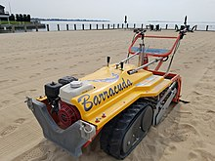

Figure 1 OLD BEACH CLEAN

## RF Controlled Beach Cleaner Robotic Vehicleproblems of old beach clean car

* **Sand Contamination:** Unable to effectively separate debris from sand, leading to excessive sand collection and increased sorting/disposal burdens.
* **Small Debris Inefficiency:** Struggled to collect small but hazardous items like cigarette butts, microplastics, and glass/plastic fragments. **Shown Figure 2**

Figure 2 FORKE BEACH CLEAN

* **High Initial Costs:** Significant upfront investment limited adoption, especially for smaller communities or organizations.
* **Limited Maneuverability:** Difficulty navigating certain beach environments with rocks, vegetation, or sensitive ecosystems.
* **Potential Ecosystem Damage:** Risk of harming fragile beach ecosystems like dune vegetation or shorebird nesting areas.
* **Embedded Debris Challenge:** Unable to remove deeply buried or embedded debris, particularly smaller items.

## the Autonomous Beach Cleaning Car

Imagine pristine beaches, free from the scourge of plastic pollution. No longer a dream, this vision becomes reality with the **Autonomous Beach Cleaning Car (ABCC)**, a pioneering innovation in environmental robotics. Our creation tackles the global crisis of marine debris head-on, utilizing cutting-edge technology to restore the health and beauty of our coastlines.

The ABCC is not just a machine; it's a champion for the environment.

* **LiDAR A1:** This advanced laser scanning system maps the beach terrain with pinpoint accuracy, guiding the ABCC around obstacles and ensuring efficient cleaning.
* **DC Motor SG-7755125000-90K:** This robust motor provides the muscle behind the ABCC's operations, powering its sweepers and suction systems as it effortlessly collects debris.
* **Raspberry Pi:** The brains of the operation, this single-board computer houses the AI algorithms that guide the ABCC's autonomous navigation and waste sorting.
* **Camera:** A vigilant eye, the camera captures real-time images of the beach, feeding data to the AI for precise waste identification and targeted cleaning.

These elements of eco-conscious innovation. The LiDAR paints a detailed picture of the beach, the sturdy motor propels the ABCC forward, the intelligent Raspberry Pi brain dictates its every move, and the keen camera ensures nothing escapes its cleaning grasp.

But the AB is more than just a technological marvel; it's a beacon of hope for a cleaner future. It represents a paradigm shift in beach cleaning, promising:

* **24/7 operation:** Unlike traditional methods, the ABCC tirelessly works around the clock, covering vast areas significantly faster.
* **Unwavering safety:** Human safety is paramount. The ABCC's autonomous operation eliminates the need for workers to brave hazardous environments.
* **Precision sorting:** Onboard AI analyzes waste in real-time, directing debris to designated compartments for efficient recycling and disposal.
* **Environmental sustainability:** Powered by solar panels, the ABCC minimizes its carbon footprint, aligning with our commitment to eco-friendly solutions.

## Objectives of the Autonomous Beach Cleaner

* Maintain high standards of cleanliness on beaches by efficiently collecting and removing debris, litter, and other waste materials.
* Minimize the need for manual labor in beach cleaning operations through automation.
* Optimize the cleaning process to cover large beach areas quickly and effectively.
* Reduce the risks associated with manual beach cleaning, including exposure to hazardous materials and extreme weather conditions.
* Promote environmental conservation by systematically removing waste that could harm marine life and ecosystems.
* Incorporate state-of-the-art technologies such as LIDAR, Kinect cameras, and advanced sensors for precise navigation and debris detection.
* Utilize energy-efficient components and power systems to minimize the environmental footprint of the cleaning operations.
* Implement systems to collect data on the types and quantities of debris collected, as well as operational performance metrics.
* Raise public awareness about the importance of maintaining clean beaches and the role of technology in environmental conservation.

# Chapter 2:

**mechatronic design of autonomous beach cleaning robot.**

The design was made with SolidWorks 2022 software system the design is mainly made of two units and two arms to pick the garbage from the beach .The control unit witch has the controller, camera and the two servo motors the servos is fixing in the sides of the unit and connected vertically with arms .

The motors unit has the 4 DC motors for the car movement and the battery connected with the battery.

Also the garbage box fixed on the top of the motor unit. Inside this box there is a mechanism fixed for emptying the collected garbage.

There is some martial stress analysis from SolidWorks software ,as shown in **figure 3.4 and 5 .**

The robot is carry on 4 wheels to give the robot stability and the tiers is designed for the heavy duty and rubber material for avoiding stick in the sand .

We took into account in our design of the project by creating a control unit in order to avoid the mixing of waste, sand and water from affecting our components, and we installed it with a tolerance for height from the ground.

## SolidWorks Parts

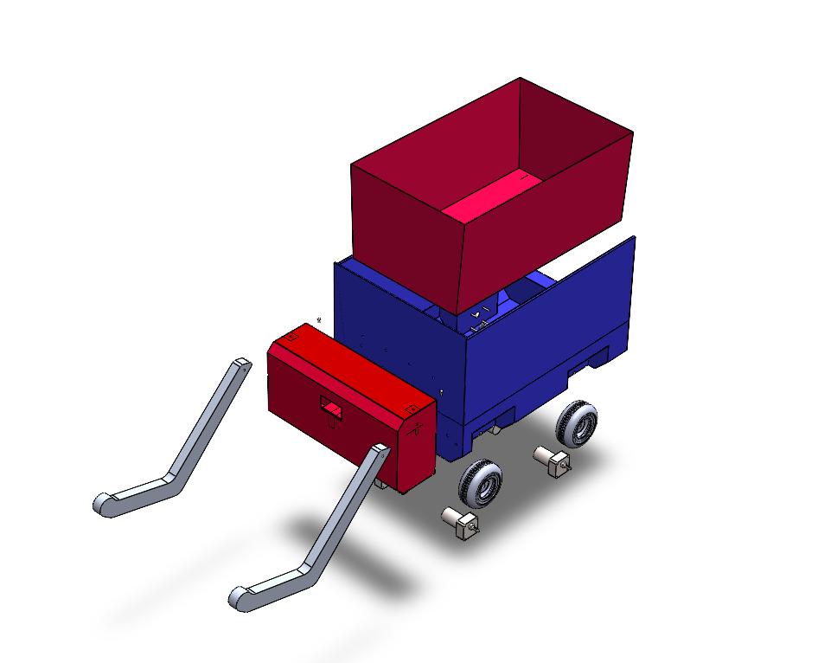

Control unit

Trach box

Motors & battery unit

Tires

DC motors

Arms

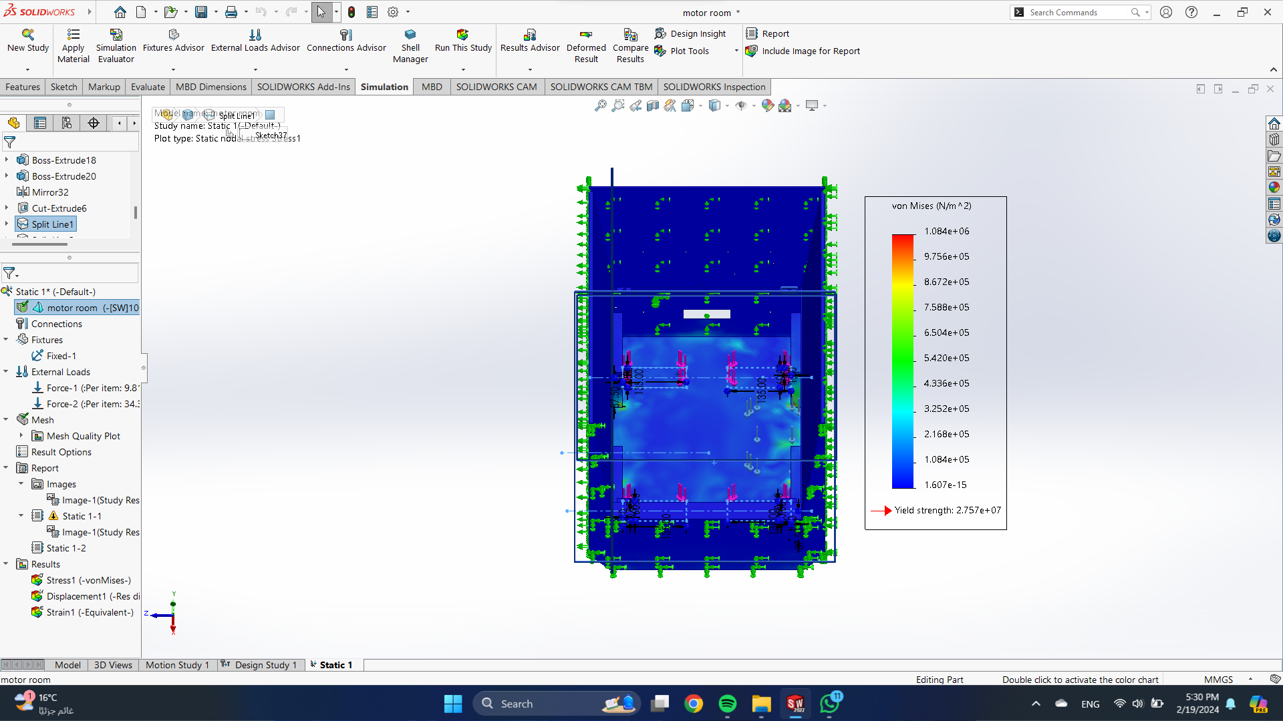

Figure 3: Motor unit stress

The yield strength for motor unit is about 2.757e+0.7

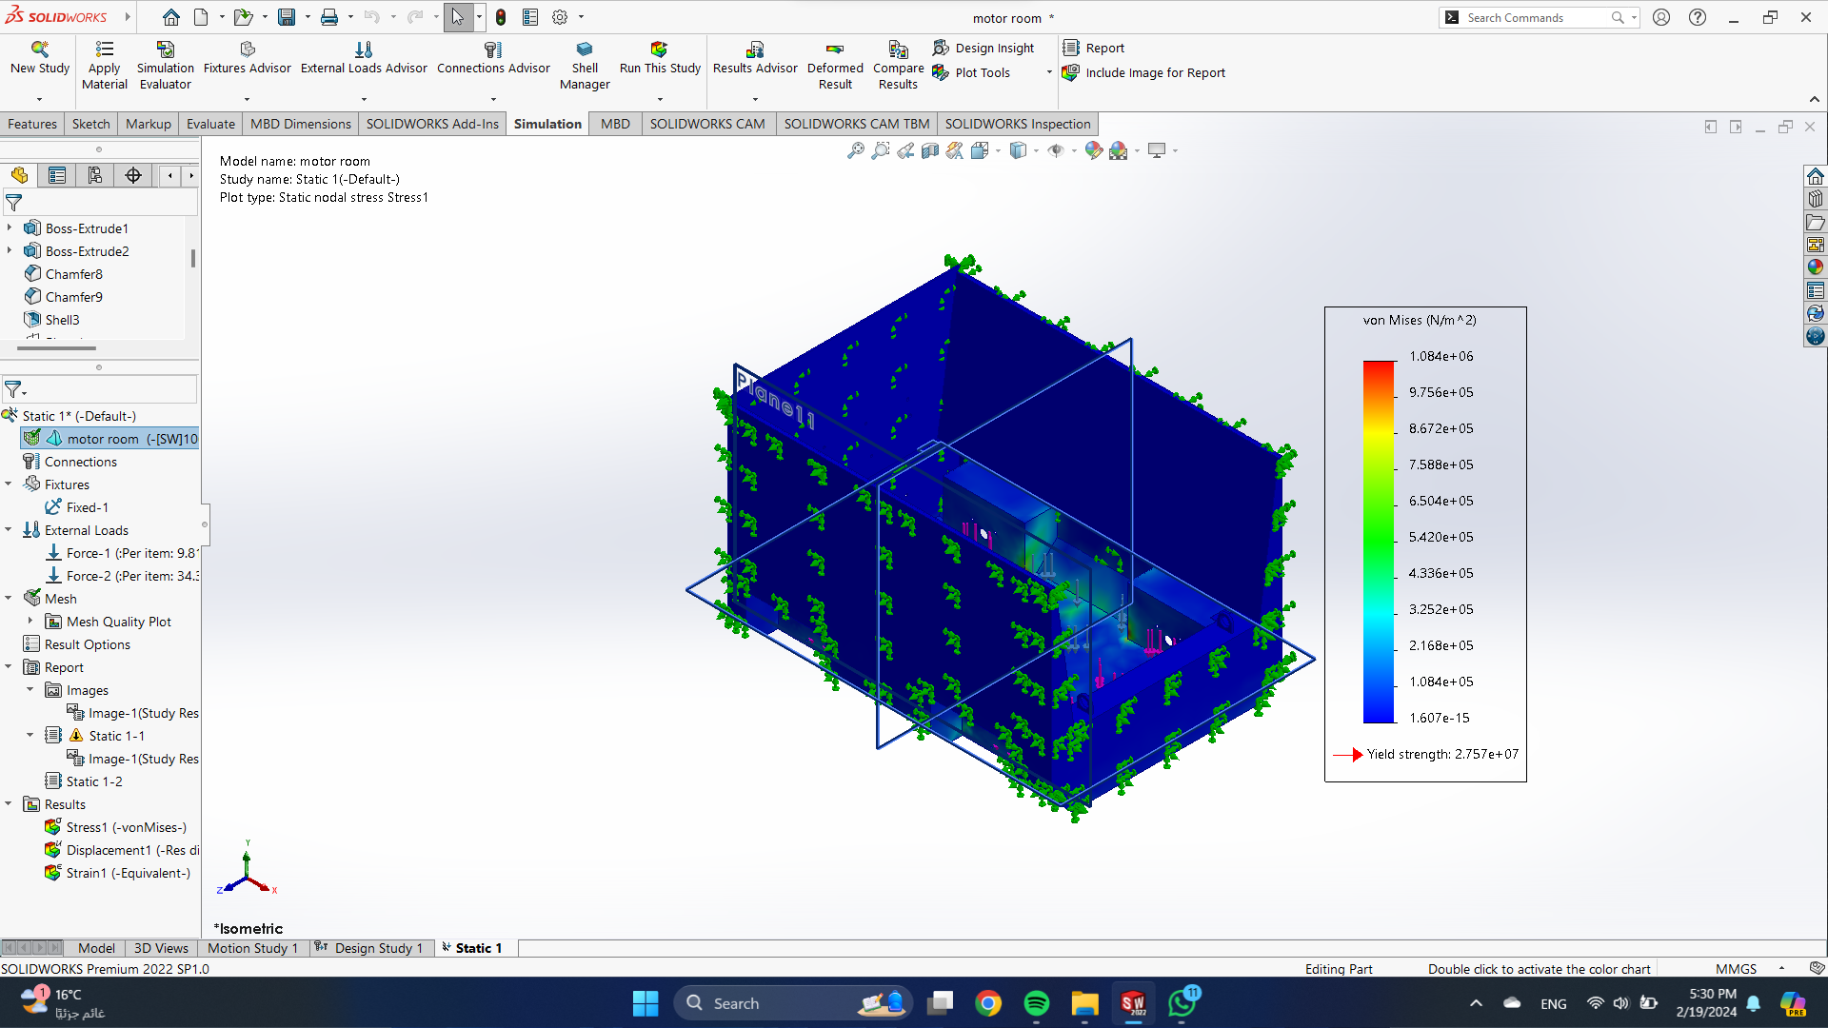

Figure 4 motor unit stresses

Another view of stress analysis

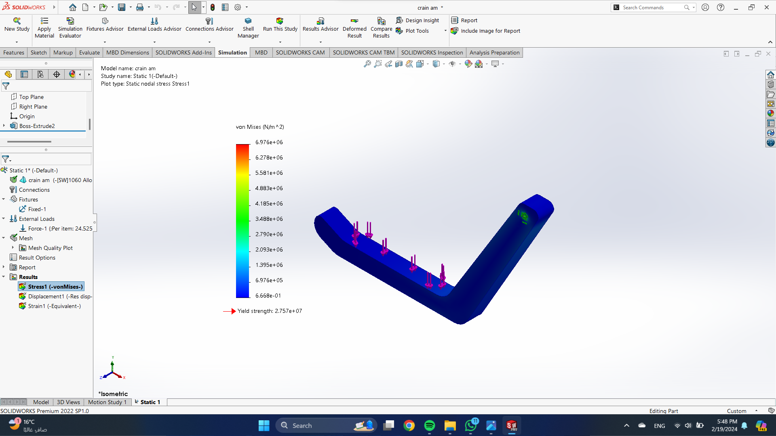

Figure 5: arm stress

The yield strength for each arm is 2.757e0.7

## motor sizing

To calculate the required torque, power, current, and battery pack for a wheeled mobile robot: the idea of vectors Power; Current and Voltage; 2D Force Balance. A wheeled robot's motors must create enough torque to overcome any irregularities in the surface or wheels, as well as friction in the motor itself, in order to roll on a horizontal surface. As a result, a robot (small or large) does not require a lot of torque to move horizontally [ 30°] . A huge robot will obviously have more friction and resistance than a tiny one. In order to a robot to roll up an incline at a constant velocity (no acceleration) it must produce enough torque to “counter act” the effect of gravity, which would otherwise cause it to roll down the incline. On an inclined surface (at an angle theta) However, only one component of its weight (mgx parallel to the surface) causes the robot to move downwards. The other component mgy is balanced by the normal force the surface exerts on the wheels. Shows in **figure6**

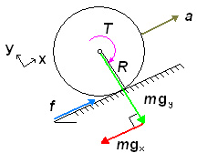

Figure 6 Explaining of torque equations

Friction between the wheel and the surface is required for the robot not to slide down the hill.

The torque is “produced” by friction (f).

mgx = mg * sin (ɵ) (2.1)

mgy = mg * cos (ɵ)

The torque (T) required is:

T = F∗ R (2.2)

Note now that all forces (F) are along the x and y axes. We balance the forces in the x-direction: ∑ 𝐹𝑥 = m ∗ 𝑎 = 𝐹 − 𝑚 ∗ 𝑔 (2.3)

**Equation for Total Torque:**

T = R * M * (a + g * sin θ) (2.4)

**Equation for Torque per Drive Motor:**

T = (a + g * sin θ) * M * R / N (2.5)

**Equation for Total Power, Considering Efficiency:**

P = (100 / e) * (a + g * sin θ) * M * R (2.6)

Explanation of Variables:

* T: Torque (in Newton-meters)
* R: Wheel radius (in meters)
* M: Robot mass (in kilograms)
* a: Desired acceleration (in meters per second squared)
* g: Gravitational acceleration (9.81 m/s²)
* θ: Incline angle (in degrees)
* N: Number of drive wheels
* e: Efficiency (as a decimal, e.g., 0.85 for 85%)
* P: Power (in Watts)

power (P) per motor can be calculated using the following equation:

p = T * ω (2.7)

T is known from above and the angular velocity (ω) is specified by the builder. It is best to select the maximum angular velocity to be able to find the corresponding maximum power. Knowing the maximum power and the supply voltage (V) which the builder chooses, we can find an idea of the maximum current (I) requirements:

p = I * V (2.8)

Finally, the capacity (c) of battery pack required can be estimated using the equation:

c = 𝐼 ∗ 𝑡 (2.9)

You may wonder why such a large value is needed. This is because when choosing a battery pack, the rated amp hours are not an accurate indicate of the maximum current

the pack can produce for extended periods of time. Also, the total charge is rarely retained over time. This way you will ensure the battery pack you select will be capable of producing the current your motors require, for the time you require and with the inefficiencies inherent in recharging battery packs.

Note: This is the battery required PER MOTOR. To obtain a total battery pack required for the robot, multiply this value by the number of drive motors.[3]

**Motor sizing calculation:**

$F_{(total)}= mg = 30×9.81 =294.3 N$

Force for each wheel $(F_{w})$

$F_{w}=\frac{F_{(total)}}{n}=\frac{294.3}{4}=73.575 N while n (number of wheels)$ (2.10)

V = 0.5 ( $m/s )$ (assumed)

V = ω × R (2.11)

While R= 0.1m

So, ω = $\frac{V}{R}$ = $\frac{0.5}{0.1}$ = 5 $( {rad}/{sec} )$

$ω=\frac{2πn}{60}$ So, N = 48 rpm

$V=V_{0}+( a× ∆t )$ (2.12)

While $V_{0}=0$ and (∆t) = 10 sec (assumed)

$$a=\frac{V}{∆t }=\frac{0.5}{10}=0.05 ( m/{s^{2}} )$$

$T = \left(\frac{100}{e} \right)× \left[a+(g× \frac{\sin{θ}}{N}) \right]× m ×R$*(2.13)*

Where:

$a$ = Acceleration = $0.05 ( m/{s^{2}} )$

g = Acceleration due to gravity = 9.81 $( m/{s^{2}} )$

N = Number of motors = 4

θ = angle of inclination. = ${18}^{◦}$

$T = \left(\frac{100}{80} \right)× \left[0.05+\left(9.81× \frac{\sin\left(18\right)}{4}\right)\right]× 30× 0.1=3 N.m$*(2.14)*

P = T × ω = 3 × 5 = 15 watt (2.15)

I = $\frac{P}{V}=\frac{15}{12}=1.25 A$

Where v (volt) = 12V

**Calculation of servo motor**

Efficiency = 90%

$$F = 4.5 * 9.81 =44.1 N$$

J = $\frac{1}{0.9 * {10}^{2}} *4.5=0.011$ Kg. $m^{2}$

ϻ = (0.1) *(44.1) * Cos (45) + [44.1 * Sin (45)] (2.16)

$F_{ext}=3.11+31.18=34.29$ (2.17)

$T_{load}=\frac{34.29}{0.9*10}$ = 3.81 (2.18)

+ 3.81 = 3.865 (2.19)

$$T_{run}=3.81$$

$T_{de}=-3.755$

$$T_{rms}=\sqrt{\frac{{3.865}^{2}*0.05+{3.81}^{2}*1+{3.755}^{2}*0.05}{0.05+1}}$$

$$T_{rms}=3.81N=0.38Kg*cm$$

## Shaft design

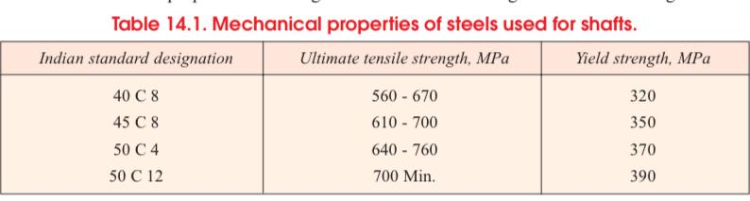

Figure 7 mechanical Properties FOR STEEL

Material for the shaft (steel 40c8)

- yield strength = 320 MPa

-Ultimate tensile strength =560 MPa

- Factor of safety = 4

**1- Find allowable stress and shear:**

$σ_{b}$ = $\frac{Syt}{f.s}$ = $\frac{320}{4}=$ 80 MPa (2.20)

τ = $\frac{0.5* Syt}{f.s}=\frac{0.5*320}{4}$ =40 MPa

* **power of motor = 15 w**

N= 48 turns

Torque = $\frac{power *60}{2πn}$ = $\frac{15 *60}{2π*48}$ = 3 N.m

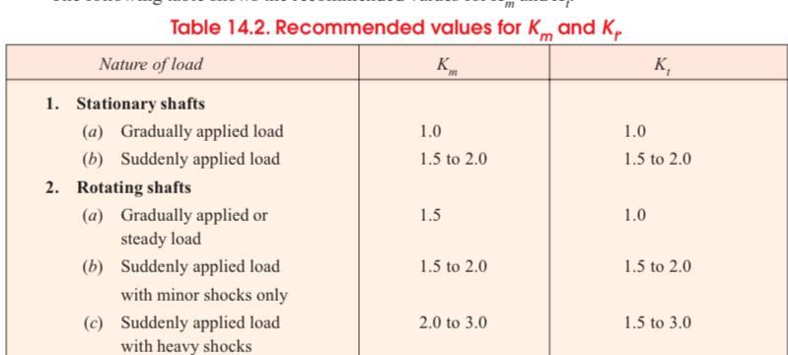

Figure 8 RECOMENDED VALUE

$$k_{m }:combined shock and fatigue factor for bending =1.5$$

$$k_{t}: combined shock and fatigue factor for torsion =1$$

(Rotating shaft): Gradually applied or steady load

Assume L= 10 cm = 10 ${10}^{-3}$*m = 100 mm

W = $\frac{30}{4}$ = 7.5 KG

M = $\frac{w*L}{4}=$ $\frac{30*9.81*100}{4}=$ 7357.5 N.mm

$τ_{e}$ = Equivalent twisting moment

$M_{e}$ = Equivalent bending moment

$τ_{e}$ = $\sqrt{{\left(Km*M\right)}^{2}+ {(Kt*T)}^{2}}$ (2.21)

= $\sqrt{{(1.5*7357.5)}^{2}+{{(1*3*10}^{3})}^{2}}$

= 11436.00718 N.mm

$M_{e}$ = $\frac{1}{2}$ [ Km*M + $\sqrt{{\left(Km*M\right)}^{2}+ {(Kt*T)}^{2}}$ (2.22)

= $\frac{1}{2}$ [ 1.5*7357.5 + $τ_{e}$] = $\frac{1}{2}$ [ 11036.25+11436.00718]

= 11236.128 N.mm

**To calculate diameter of shaft**

$τ_{e}= \frac{π}{16}$* τ $d^{3}$* (2.24)

11436.00718 = $\frac{π}{16}$* 40 $d^{3}$

*

*d* = 11.3343mm ≈ 12mm

$M_{e}= \frac{π}{32}$ $σ_{b}$ $d^{3}$* * (2.25)

11236.128 = $\frac{π}{32}$* 80 $d^{3}$

*

*d* = 11.267 ≈ 12mm

$k_{a}=a* s_{ut}^{b}=57.7* {\left(560\right)}^{-0.718}=0.613$

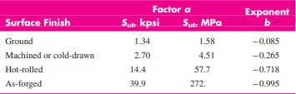 a and b from table

$s_{ut} \left(tensile strength \right)=560 MPa$

Table 1 materials comparing

1. 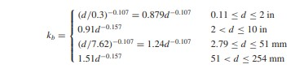From the calculation we find shaft diameter d=12mm

So, $k_{b}={(\frac{12}{7.62})}^{-0.107}$

$$k_{b}=0.952$$

Equation from table

1. 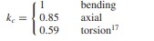There is a bending force on the shaft

$k_{c}=1$ from table

1. $k_{d}=0.975+0.432{*\left(10\right)}^{-3} T_{f}-0.115*({10)}^{-5}T_{f}^{2}$ + 0.104*(${10)}^{-8}T_{f}^{3}-0.595*({10)}^{-12}T_{f}^{4}$

Our robot will work outdoor so, T= ${35}^{◦}c$

Which = ${95}^{◦}f$



$$c^{◦}=\frac{\left(f^{◦}-{32}^{◦}\right)}{1.8} ⟶ {35}^{◦}=\frac{\left(f^{◦}-{32}^{◦}\right)}{1.8}$$

$$K_{d}=1.0065≈1$$

$K_{e} :from table$

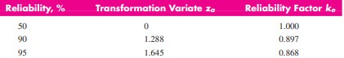reliability =90%

Table 2 table of Ke

$$K_{e}=0.897$$

1. Take $K_{f}=1 :from table$

${S^{'}}_{e}=0.5 sut at {10}^{6}cycles \left[For steels\right]$

Sut: tensile strength = 560 MPa

$${S^{'}}_{e}=0.5*560=280 MPa$$

$$S_{e}= K_{a}* K_{b}*K_{c}*K_{d}*K_{e}*K_{f}* {S'}_{e}$$

= (0.613) *(0.952) * (1) * (1) * (0.897) * (1) * (280)

=147.52 MPa [4]

# ELECTRONICS COMPONENTS & CIRCUIT

The Autonomous Beach Cleaning Car is an innovative project aimed at enhancing the efficiency and effectiveness of beach cleaning operations. This vehicle is designed to navigate autonomously across sandy terrains, identifying and collecting debris, thus maintaining the cleanliness of beach environments with minimal human intervention. The key components and their functionalities are detailed below

The base of the beach cleaning car is constructed from aluminum sheet metal. This material was chosen for its combination of light weight and durability, ensuring the vehicle can operate efficiently while withstanding the harsh conditions of a beach environment.

## Electronics Components

### LIDAR

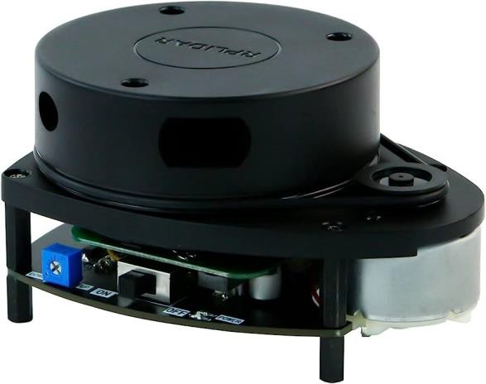lidar is currently the most popular and cost-effective lidar in the open-source hardware field. It possesses small size and excellent quality, support 360° scanning and distance measurement, can be used on a personal computer or Jetson NANO Raspberry Pi and other micro-controllers by a USB data cable. We will provide many tutorial materials and codes, and ROS robot learning materials. These lidar are divided into 6 different models, each of which has a different shape and performance, and users can choose according to their requirements. Showen I **figure 9**

Figure 9 Light detection and ranging

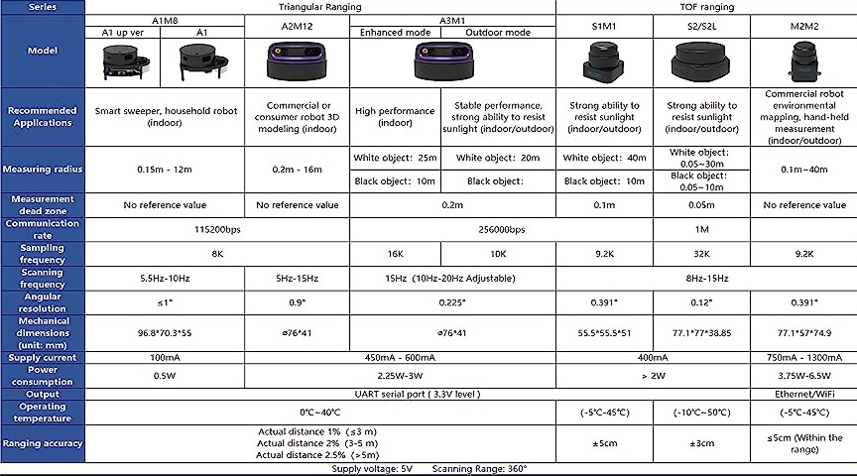

Figure 10LIDAR Parameter Comparison

Table 3LIDAR Parameter Comparison

|  |  |  |  |
| --- | --- | --- | --- |
| Feature | Lidar A1 (*) | Lidar A2 | Lidar A3 |
| **Scanning method** | Time-of-flight (TOF) | TOF | Phase shift (PS) |
| **Range** | 12 m | 16 m | 25 m |
| **Angular Resolution** | ≤1° | 0.225 ° | 0.225 ° |
| **Accuracy** | - 0.01 of actual distance (**≤** 3 m)  - 0.02 of actual distance (3-5 m)  - 0.25 of actual distance (5-12m) | - 0.01 of the  range (**≤** 3 m)  - 0.02 of the range (3-5 m)  - 0.25 of the range(5-25m) | - 0.01 of the  range (**≤** 3 m)  - 0.02 of the  range (3-5 m)  - 0.25 of the  range(5-25m) |
| **Applications** | indoor environment and outdoor environment without sunlight. | indoor environment and outdoor environment without direct sunlight | Outdoor |
| **Protection Rating** | IP40 | IP65 | IP65 |

### DC Motor 12V with Gearbox

We use 12V DC motor and 4.0amp rated current, which is powerful. motor that gives us the needed torque (38.6 Kgf.cm) and suitable speed of 56 r/min with a 1:60 metal gearbox. The gears are all steel and the output shaft is 8mm diameter. The motor has extra rear shaft (on the high-speed side before the gearbox) which allow you to mount motor encoder for feedback of motor speed. **Showen in figure 11**

#### *Specifications*

* + - * Rated voltage: 12VDC.
      * No load speed: 56 r/min
      * Rated speed: 42 r/min.
      * Load torque current: 4 A
      * Rated torque: 38.6 kgf.cm = 3.78 N

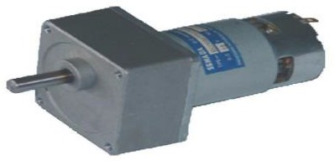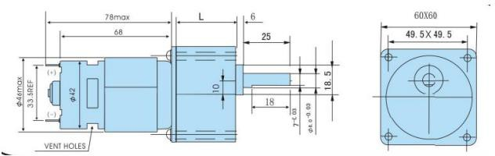

Figure 11 DC Geared Motor with Dimensions

### DC Motor Driver (Citron MDD 10A)

MDD10A shipped after Jan 2017 is in Rev2.0 which motor supports up to 30VDC. DC brushed motor is the most commonly used and widely available motor in the market. Getting the motor to rotate is fairly easy, just connect the two terminals to power source and it will start spinning, that's the beauty of DC brushed motor. Yet, if you want to control the speed, direction, activation and automate all these functions, check out this tutorial: [5 easiest ways to control a DC](https://www.cytron.io/tutorial/5-easiest-ways-control-dc-motor) [motor](https://www.cytron.io/tutorial/5-easiest-ways-control-dc-motor). using a motor driver is one of the ways. MDD10A is one of Citron’s motor driver series which offers easy-to-use features, and it can drive two independent motors. **Figure 12**

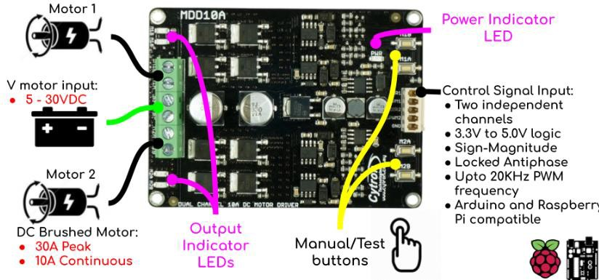

Figure 132 Dual Channel 10Amp DC Motor Driver

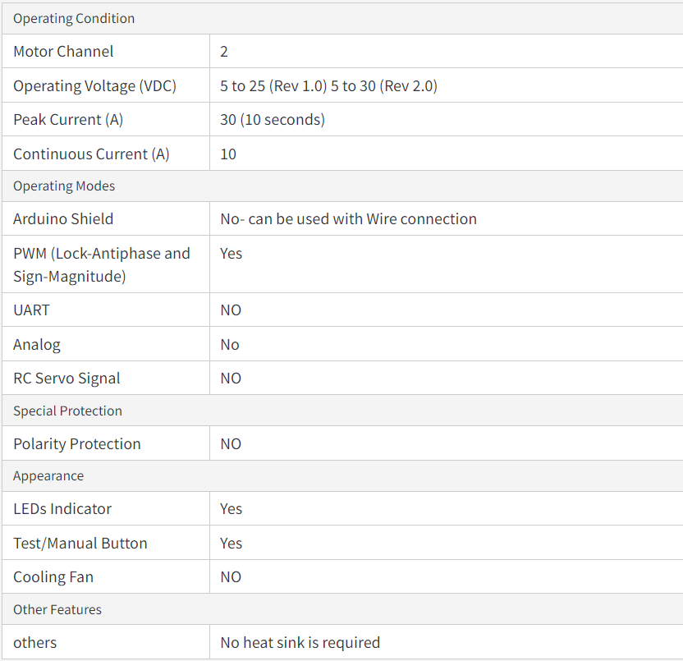

Table 4 Specifications of Cytron MDD 10A

### Raspberry Pi 4 Model B

The Raspberry Pi 4 offers ground-breaking increases in processor speed, multimedia performance, memory, and connectivity compared to the prior-generation boards, while retaining backwards compatibility and similar power consumption. The Raspberry Pi 4 provides desktop performance comparable to entry-level x86 PC systems. The Raspberry Pi 4 comes in three on- board RAM options for even further performance benefits: 2GB, 4GB and 8GB. As in **figure 13**

**Features of Raspberry Pi computer, we can note:**

* A high-performance 64-bit quad-core processor
* Dual display support with resolutions up to 4K via a pair of micro-HDMI ports
* Hardware video decoding up to 4Kp60.
* 8 GB of RAM
* A connection to the dual-band wireless local area network 2.4/5.0 GHz
* Bluetooth 5.0 / Gigabit Ethernet / USB 3.0 / PoE features (via a separate HAT PoE add-on module)

**Specifications**

* SoC Broadcom BCM2711, quad-core Cortex-A72 (ARM v8) 64-bit at 1.5GHz
* SDRAM 8 GB LPDDR4-2400
* Wireless LAN 2.4 GHz and 5.0 GHz IEEE 802.11b/g/n/ac, Bluetooth 5.0, BLE
* True Gigabit Ethernet
* 2 USB 3.0 ports, 2 USB 2.0 ports
* Fully backward compatible 40-pin GPIO connector
* 2 HDMI micro ports supporting video resolution up to 4K 60Hz.
* 2-way MIPI DSI DSI/CSI ports for camera and display
* Stereo audio output and composite video port, 4-pole
* Slot for Micro SD card, for operating system and data storage
* Requires 5.1V, 3A power supply via USB-C or GPIO
* PoE (Power over Ethernet) enabled (requires PoE HAT)

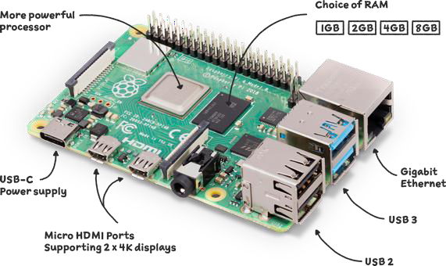

Figure 143 Raspberry Pi 4 Model B

Table 5 Compare with raspberry pi.

|  |  |  |  |  |  |
| --- | --- | --- | --- | --- | --- |
| Feature | Raspberry Pi Zero | Raspberry Pi 1 | Raspberry Pi 2 | Raspberry Pi 3 | Raspberry  Pi 4 |
| CPU | Broadcom BCM2835 | Broadcom BCM2835 | Broadcom BCM2836 | Broadcom BCM2837 | Broadcom BCM2711 |
| CPU Architecture | 32-bit | 32-bit | 32-bit | 32-bit | 64-bit |
| Cores | 1 | 1 | 4 | 4 | 4 |
| Clock Speed | 700 MHz | 700 MHz | 900 MHz | 1.2 GHz - 1.4 GHz | 1.5 GHz |
| RAM | 512 MB | 512 MB | 1 GB | 1 GB | 2 GB, 4 GB, or 8 GB |
| Storage | MicroSD card | MicroSD card | MicroSD card | MicroSD card | MicroSD card |
| USB Ports | 1 x USB 2.0 | 1 x USB 2.0 | 4 x USB 2.0 | 4 x USB 2.0 | 4 x USB 2.0 |
| Ethernet | No | Yes | Yes | Yes | Yes |
| Wireless | None | None | No | Wi-Fi 802.11n | Wi-Fi 802.11ac |
| Bluetooth | None | None | No | Bluetooth 4.1 | Bluetooth 5.0 |
| Video Output | Micro HDMI | Micro HDMI | Micro HDMI | Micro HDMI | 2x Micro HDMI |

Table 6 Compare with raspberry pi 4 (a & b)

|  |  |  |
| --- | --- | --- |
| Feature | Model A | Model B (*) |
| RAM | 512MB | 2GB, 4GB, or 8GB |
| USB Ports | 1 x USB 2.0 | 4 x USB 2.0 |
| Ethernet | No | Yes |
| Wireless | None | Wi-Fi 802.11ac and Bluetooth 5.0 |
| **Video Output** | Micro HDMI | 2 x Micro HDMI |

### ESP32

ESP32 is created by Espresso Systems with a series of SoC (System on a Chip) and modules which are low cost with low power consumption. This new ESP32 is the success to the well-known ESP8266 (became extremely popular with its input Wi-Fi). ESP32 not only has Built in Wi-Fi but also has Bluetooth and Bluetooth Low Energy. In other words, we can define ESP32 as “ESP8266 ”. ESP32 chip ESP32-D0WDQ6 is based on a Tensilica Xtensa LX6 dual core microprocessor with an operating frequency of up to 240 MHz as in **figure 14**

The small ESP32 package has a high level of integrations such as:

* Antenna switches
* Balun to control RF
* Power amplifier
* Low noise reception amplifier
* 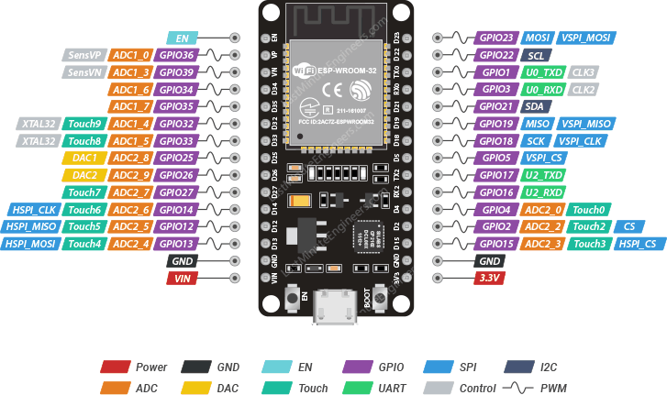Filters and power management modules

Figure 154 ESP32 Pinout

### Wire connector 2 in 8

* Safety and reliability: DIN rail terminal blocks are made from insulated material, flame- retardant, corrosion resistance, aging resistance, high pressure resistance. Strong structure firmly locked to DIN guide, long service life.
* Product feature: Wire splicers instead of the ordinary rail connector, reduce the wiring time by 50~70% with our modern design. The wire connectors support a variety of installation methods (guide rail and screw mount). Make the connection easier faster and lower maintenance cost.
* Widely applicable: Lever wire connectors can be used for home appliance, lighting, electrical control, power supply, switches, machinery and other wire connection parts. Every junction independent shrapnel, different wire managed separately, improving safety performance.

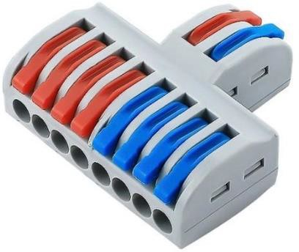

Figure 165 Wire connector

### XL4015 DC-DC Buck Converter Module

one such application is charging a lithium battery at a constant current using this module with ease. It’s also a good idea to use a constant current when you’re testing a circuit for the first time, so that any mistakes you might have made in the build process can be minimized. The device’s PWM can reach 100% duty cycle and 180 kHz operating frequency at full load. The module has a 5A output current and can operate at up to 96 percent efficiency. Thermal shutdown, short circuit protection, and current limit are all included in the device’s safety features. Showen in **figure 16**

#### *Specification*

* Output voltage: 0.8V-30V
* Input voltage: 5V-32V
* Output current: adjustable maximum 5A
* Size: 51 * 26.3 * 14 (L * W * H) (mm)
* Operating Temperature: -40 â„ƒ to +85 â„ƒ
* Voltage Regulation: ± 2.5%
* Load Regulation: ± 0.5%
* Switching frequency: 300KHz
* 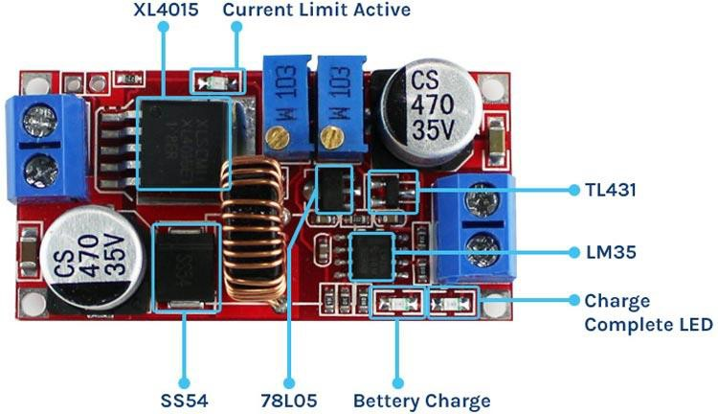Conversion efficiency: 95% (the highest)

Figure 176 Buck Converter Module

#### 

### SERVO Motor FT5836M

the FEETECH 35Kg Coreless Servo Motor is a high-torque, digital servo motor that is designed for use in a variety of applications, including robots, RC cars, boats, and drones. It is made with a coreless motor and metal gears, which makes it durable and powerful. It is also waterproof and has a wide range of motion, making it suitable for use in a variety of conditions. Showen in **figure 17**

**Specifications**

* Voltage: 6V-7.4V
* Torque: 35kg-cm at 7.4V
* Speed: 0.19sec/60° at 7.4V
* Operating temperature: -20°C to +60°C
* Dimensions: 55 x 20 x 43mm
* Weight: 75g

**Connection:**

* Orange: PWM
* 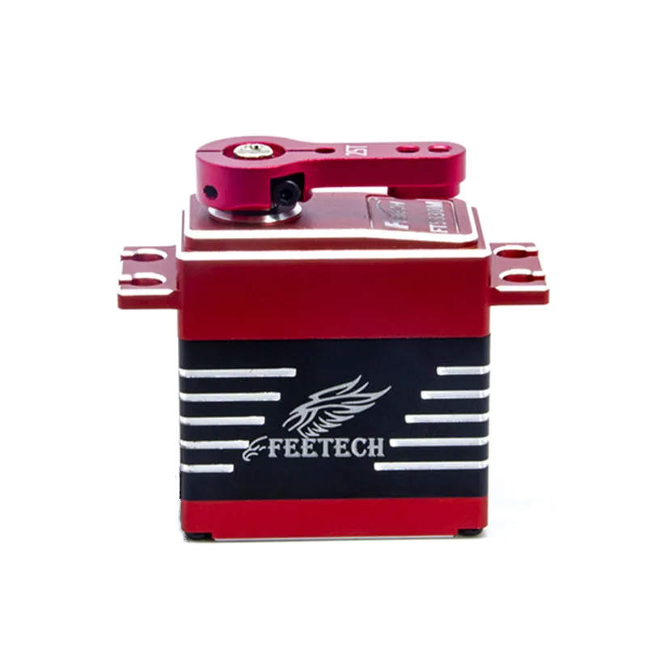Red: VCC
* Brown: GND

Figure 187 Servo Motor

### lithium-ion battery

A lithium-ion or Li-ion battery is a type of [rechargeable battery](https://en.wikipedia.org/wiki/Rechargeable_battery) which uses the reversible [reduction](https://en.wikipedia.org/wiki/Redox) of [lithium](https://en.wikipedia.org/wiki/Lithium) [ions](https://en.wikipedia.org/wiki/Ion) to store energy. The negative electrode of a conventional lithium-ion cell is typically [graphite](https://en.wikipedia.org/wiki/Graphite), a form of [carbon](https://en.wikipedia.org/wiki/Carbon). This negative electrode is sometimes called the [anode](https://en.wikipedia.org/wiki/Anode) as it acts as an anode *during discharge*. The positive electrode is typically a metal [oxide](https://en.wikipedia.org/wiki/Oxide); the positive electrode is sometimes called the [cathode](https://en.wikipedia.org/wiki/Cathode) as it acts as a cathode *during discharge*. Positive and negative electrodes remain positive and negative in normal use whether charging or discharging and are therefore clearer terms to use than anode and cathode which are reversed during charging. Showen in **figure 18**

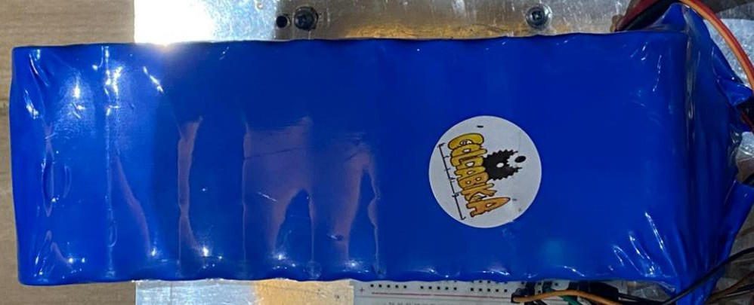

Figure 19 lithium-ion Battery

### Kinect Camera:

#### Kinect is a line of motion sensing input devices produced by Microsoft and first released in 2010. The devices generally contain RGB cameras, and infrared projectors and detectors that map depth through either structured or time of flight calculations, which can in turn be used to perform real-time gesture recognition and body skeletal detection, among other capabilities. They also contain microphones that can be used for speech recognition and voice control.

Kinect has also been used as part of non-game applications in academic and commercial environments, as it was cheaper and more robust compared to other depth-sensing technologies at the time. While Microsoft initially objected to such applications, it later released software development kits (SDKs) for the development of Microsoft Windows applications that use Kinect. In 2020, Microsoft released Azure Kinect as a continuation of the technology integrated with the Microsoft Azure cloud computing platform. Part of the Kinect technology was also used within Microsoft's Hololens project. Microsoft discontinued the Azure Kinect developer kits in October 2023 showes in **figure 19**

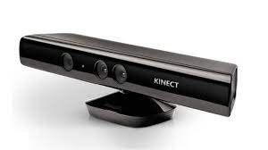

Figure 20 kinetic Camera

# Stepper Motor (NEMA 17 - 3 Kg.cm)

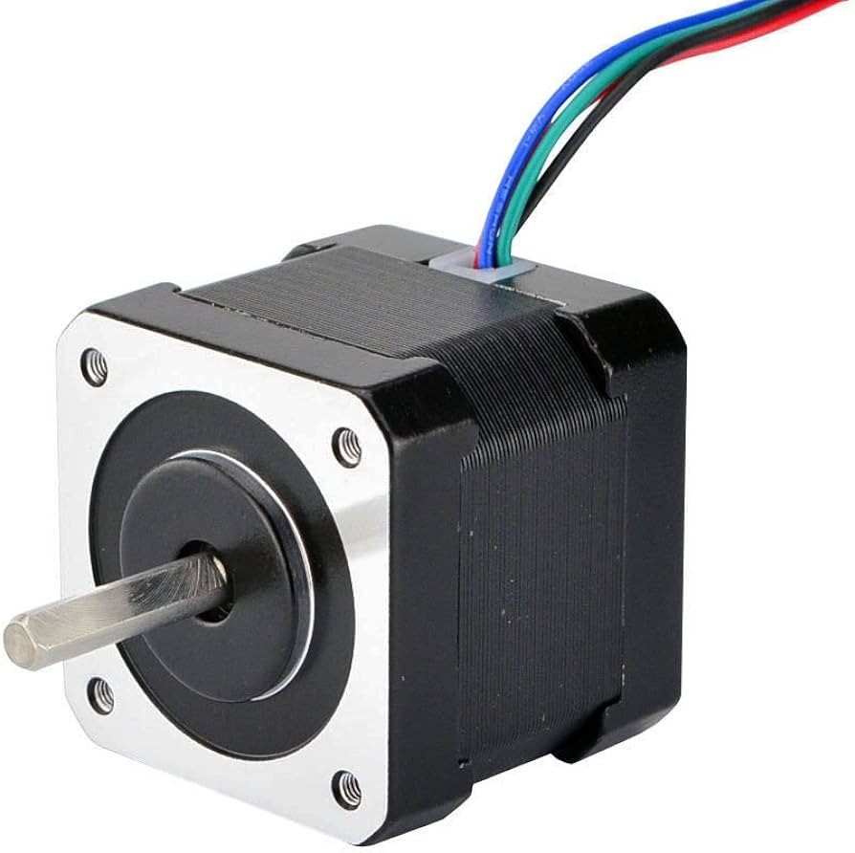This 4-wire bipolar stepper has 1.8° per step for smooth motion and 3 kg.cm holding torque. The motor was specified to have a max current of 350mA so that it could be driven easily with

Figure 21 NEMA 17 steper motor

Some nice details include a ready-to-go cable and a machined drive shaft (so you can easily attach items). Showen in **figure 21**

* 200 steps per revolution, 1.8 degrees
* Bipolar stepper
* 4-wire, 12 inch leads
* 42mm/1.65" square body
* 31mm/1.22" square mounting holes, 3mm metric screws (M3)
* 5mm diameter drive shaft, 24mm long, with a machined flat
* 12V rated voltage (you can drive it at a lower voltage, but the torque will drop)
* Max current:  350mA
* 30 N*cm, 3 Kg*cm holding torque per phase
* 35 ohms per winding

## ****IR Sensor****

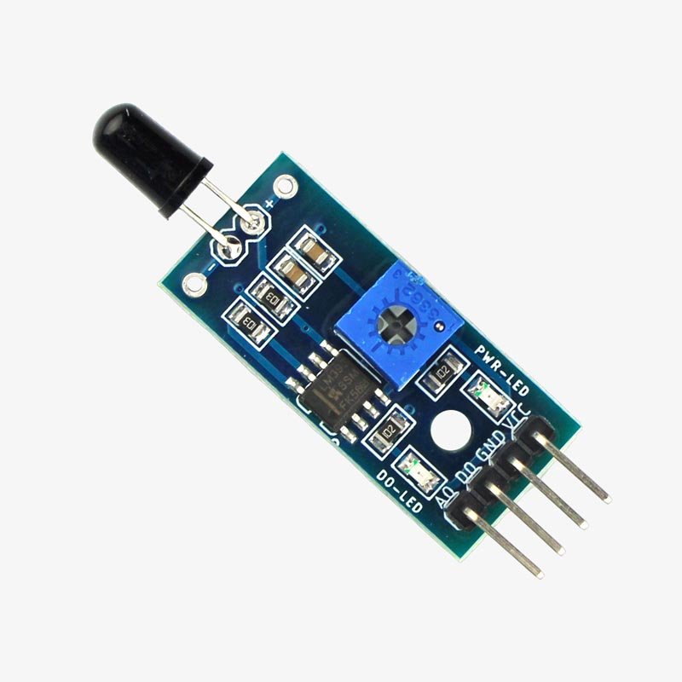An IR sensor is an electronic device that detects IR radiation falling on it. [Proximity sensors](https://www.electronicsforu.com/videos-slideshows/introduction-proximity-sensor) (used in touchscreen phones and edge-avoiding robots), contrast sensors (used in line following robots), and obstruction counters/sensors (used for counting goods and in burglar alarms) are some applications involveing IR sensors. As **figure 22**

Figure 22 IR sensor

1. **A4988 stepper motor driver**

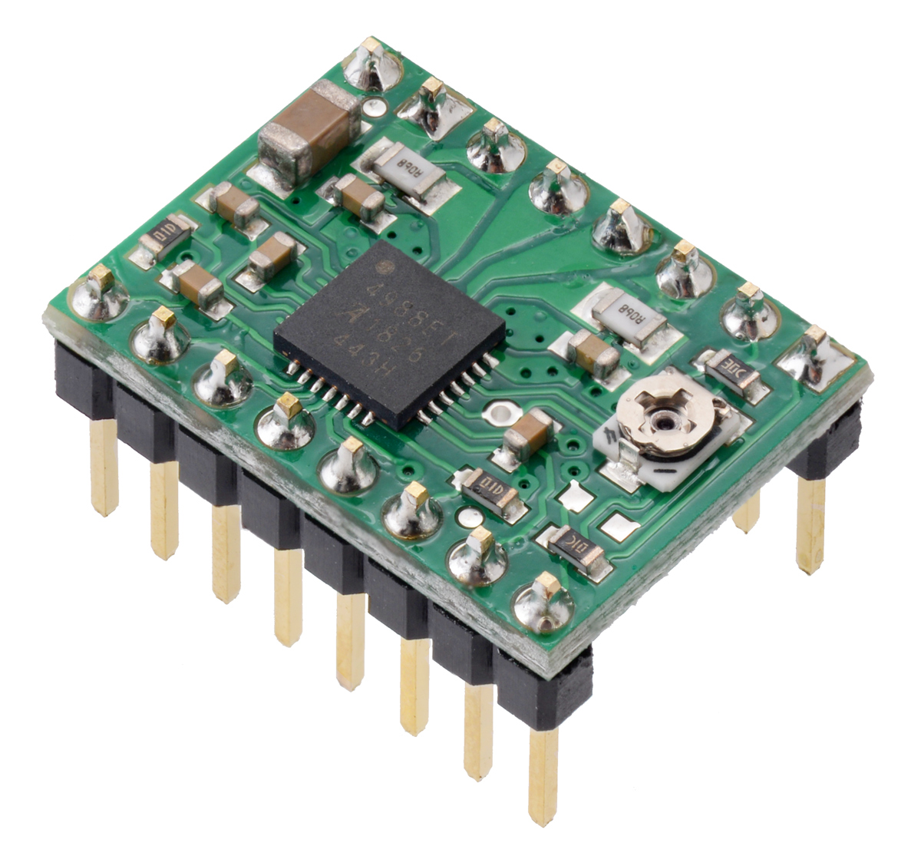The A4988 stepper motor driver has an output drive capacity of up to 35V and ±2A. This allows you to control a bipolar stepper motor, such as the NEMA 17, at up to 2A output current per coil. As **figure 23**

Figure 23 A4998 driver

1. **IMU**

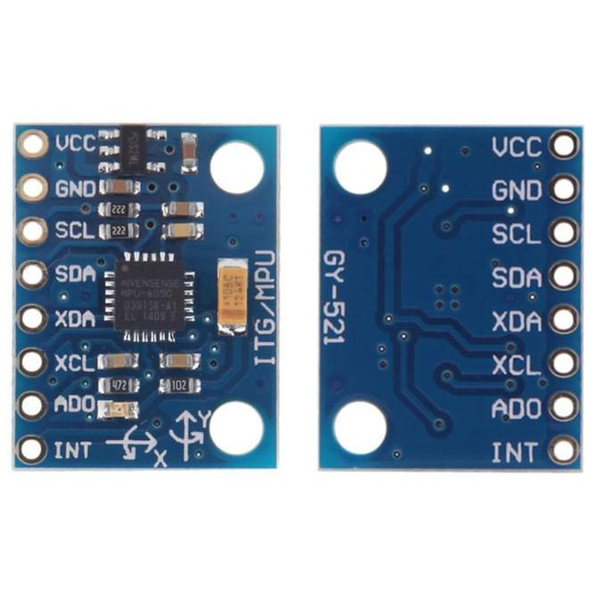The CS-IM100/200 Inertial Measurement Unit is a 9 degree-of-freedom (DOF) inertial measurement device. The 3-axis accelerometer can be used to sense gravitational acceleration as well as motion. Rotation-rate can be sensed by the 3-axis gyroscope and the magnetometer provides 3-axis measurements of the magnetic field. This calibrated MEMS sensing combination provides a wealth of dynamic measurements to support a wide range of applications. The CS-IMxxx is a cost effective option packaged with a robust housing, interface options, and a simple set up. Showen In **figure 24** [5]

Figure 24 IMU 5060

## Calculations of Battery sizing:

E = V * I * t = 12 * [ (4 * 4) + (4* 2) + (10.2*1)] * 1 = 410.4 W-H (2.24)

Q = $\frac{ E* t}{ V* e}$ = $\frac{410.4}{12*0.80}=42.75 Ah$ (2.25)

The battery capacity is equal to 42.75 *Ah*

where:

E– Energy stored in a battery, expressed in watt-hours;

V– Voltage of the battery; and

Q– Battery capacity, measured in amp-hours.

e– Efficiency [6]

## Calculations of Maximum current:

I(max) = $\frac{P}{V}=\frac{\left(16*4\right)+\left(15*2\right)}{12}=7.8334 A$ (2.27)

## Flow chart:

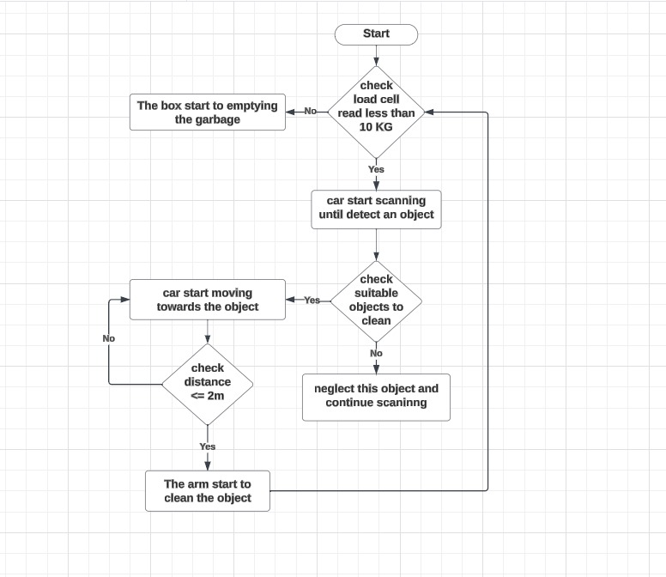

Figure 25 Flow chart

## Circuit Diagram in Fritzing:

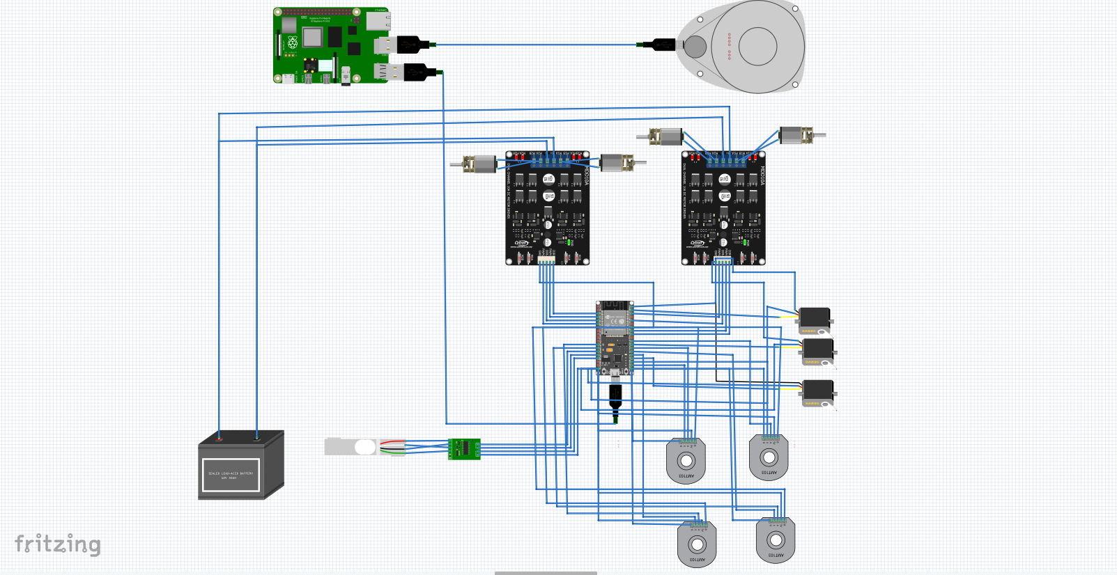

Figure 26 Circuit Diagram

## Circuit Diagram in Eagle:

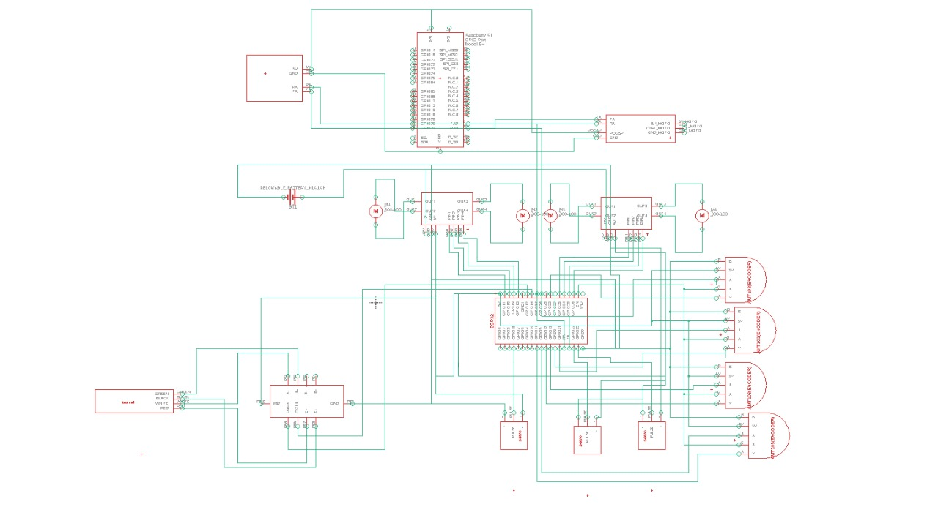

Figure 27 Circuit Diagram

# Chapter 3:

# Robot Operating System

In this Chapter we will be going through and introduction about ROS, its objectives, terminologies used in it and how to create and initialize a workspace.

We will go step by step in the installation of ubuntu 20.04, and ROS to begin creating the packages needed later on with the project.

Explain how ROS communicates, and how nodes, topic, services work.

As well as the most used tools that are used while testing a package in ROS to visualize the data coming from simulation or hardware.

## Introduction

Robots are made up of numerous functioning components and require specific knowledge in a variety of domains. As a result, several technical constraints must be addressed, and extra study is required before robots may be employed in everyday life. Not just professionals, but also companies in adjacent industries and common users, must work together to achieve this. We require a platform for collaboration and technical progress in addition to the implementation and use of robots. ROS has various elements for spreading and lowering entry barriers to technology.

ROS is an open-source, meta-operating system for your robot. It provides the services you would expect from an operating system, including hardware abstraction, low-level device control, implementation of commonly used functionality, message-passing between processes, and package management. It also provides tools and libraries for obtaining, building, writing, and running code across multiple computers.

ROS stands for Robot operating system, those who are unfamiliar with ROS may mistakenly believe it is identical to the operating systems like windows or iOS.

A more appropriate description of ROS is that it is a Meta-Operating System. Although the word "meta-operating system" is not defined, it refers to a system that uses a virtualization layer between applications and distributed computing resources to accomplish tasks such as scheduling, loading, monitoring, and error handling.

## Objective of ROS

The goal of ROS is to “build a development environment that allow robotic software development to collaborate on a global level”. In order to maintain a large code base which can be unmanageable in some cases in the robotics field, as well as an extremely tight coupling between different areas of the system’s functionality. Since there are many interfaces and components in our system that would raise integration complexity, ROS was the appropriate choice because we wanted to avoid writing an unwieldy program which would be hard to maintain.

ROS sits on top of Linux and is used as a collection of software frameworks for robotic control and communication. Packages are a unit of organization of ROS code that contains source code for ROS nodes. Nodes are executables that run the software for the system and have the ability to communicate with other nodes; To communicate between nodes, ROS uses a publisher/subscriber model. Although ROS supports a variety of opera ting systems, since Ubuntu is the most widely used among ROS users.

### ROS Installation

In this section we will go through ROS installation noetic version. Setup your sources. List Setup your computer to accept software from packages.ros.org.

* sudo sh -c 'echo "deb <http://packages.ros.org/ros/ubuntu> $(lsb_release -sc) main" >

/etc/apt/sources.list.d/ros-latest.list'

**Set up your keys**

* sudo apt install curl # if you haven't already installed curl
* curl -s https://raw.githubusercontent.com/ros/rosdistro/master/ros.asc | sudo apt- key add -

**Installation**

First, make sure your Debian package index is up to date:

* sudo apt update

**Now pick how much of ROS you would like to install.**

**Desktop-Full Install: (Recommended)** : Everything in **Desktop** plus 2D/3D simulators and 2D/3D perception packages

sudo apt install ros-noetic-desktop-full

**Desktop Install:** Everything in **ROS-Base** plus tools like [rqt](http://wiki.ros.org/rqt) and [rviz](http://wiki.ros.org/rviz)

o sudo apt install ros-noetic-desktop

**ROS-Base: (Bare Bones)** ROS packaging, build, and communication libraries. No GUI tools.

o sudo apt install ros-noetic-ros-base

There are even more packages available in ROS. You can always install a specific package directly.

* sudo apt install ros-noetic-PACKAGE

**example:**

sudo apt install ros-noetic-slam-gmapping

**To find available packages use:**

apt search ros-noetic

Environment setup You must source this script in every **bash** terminal you use ROS in.

source /opt/ros/noetic/setup.bash

If you have more than one ROS distribution installed, ~/.bashrc must only source the setup.bash for the version you are currently using.

echo "source /opt/ros/noetic/setup.bash" >> ~/.bashrc

source ~/.bashrc

#### *zsh*

echo "source /opt/ros/noetic/setup.zsh" >> ~/.zshrc

source ~/.zshrc

**Dependencies for building packages**

Up to now you have installed what you need to run the core ROS packages. To create and manage your own ROS workspaces, there are various tools and requirements that are distributed separately. For example, [rosinstall](http://wiki.ros.org/rosinstall) is a frequently used command-line tool that enables you to easily download many source trees for ROS packages with one command.

sudo apt install python3-rosdep python3-rosinstall python3-rosinstall-generator python3- wstool build-essential

**Initialize rosdep**

Before you can use many ROS tools, you will need to initialize rosdep. rosdep enables you to easily install system dependencies for source you want to compile and is required to run some core components in ROS. If you have not yet installed rosdep, do so as follows.

sudo apt install python3-rosdep

**With the following, you can initialize rosdep.**

sudo rosdep init

rosdep update

**For more information visit** [**ROS Wiki kinetic installation.**](http://wiki.ros.org/kinetic/Installation/Ubuntu)

## Creating and Initializing a Workspace Folder

Noetic, a specific build system for ROS, is used. To utilize it, create and

establish a catkin workspace folder as shown below. this configuration only needs to be done once.

$ mkdir -p ~/catkin_ws/src

$ cd ~/catkin_ws/src

$ catkin_init_workspace

Now that we have created the catkin workspace folder, let’s build it.

$ cd ~/catkin_ws/

$ catkin_make

Once you have finished building without errors, ‘build’ and ‘devel’ folders have been created. The build related files for the catkin build system are saved in the ‘build’ folder, and the Lastly, we will import the setting file associated with the catkin build system.

$ source ~/catkin_ws/devel/setup.bash

## ROS Terminologies

This section explains the most frequently used ROS terms. It’s preferable to be familiar with these concepts in order to know what exactly you are working with. You will become more familiar with the concepts as you engage with more and more practices.

#### *ROS(Master , Core) :*

ROS (Robot Operating System) master and roscore are closely related but they are not the same thing.

roscore is a command-line tool that initializes the ROS environment by starting up several core ROS nodes including the ROS Master, Parameter Server, and the rosout logging node. When you run the roscore command, it starts the ROS Master node as well as other essential nodes required for ROS communication.

The ROS Master is a crucial component of the ROS communication system. It is responsible for maintaining a directory of available ROS nodes, topics, and services, as well as providing a mechanism for nodes to find each other and communicate with each other.

The ROS Master keeps track of all the active ROS nodes in the system, and it also provides a central point for resolving naming conflicts. Whenever a new node is started, it registers with the ROS Master, which then adds the node to its registry of active nodes. The ROS Master also provides a centralized namespace for all nodes, topics, and services in the ROS system, which helps prevent naming conflicts between different nodes.

In summary, roscore is a tool used to start the ROS environment, which includes the ROS Master, Parameter Server, and the rosout logging node. The ROS Master, on the other hand, is a critical component of the ROS communication system that maintains a directory of available ROS nodes, topics, and services and provides a mechanism for nodes to find and communicate with each other

#### Node

The smallest processor unit in ROS is referred to as a node. Consider it a single executable application. It is recommended by ROS to create a single node for each purpose and to develop for easy reusability. In the case of mobile robots, for example, the operating program is divided down into specific functions. Sensor drive, sensor data conversion, obstacle detection, motor drive, encoder input, and navigation are all handled by specialized nodes.

Upon startup, a node registers information such as name, message type, URI address and port number of the node. The registered node can act as a publisher, subscriber, service server or service client based on the registered information, and nodes can exchange messages using topics and services.

#### Package

A package is the basic unit of ROS. The ROS program is built as a set of packages, each of which contains either a configuration file for launching other packages or a set of nodes. All of the files required to operate the package are also included, including ROS dependent libraries for running various processes, datasets, and a configuration file.

#### Metapackage

A metapackage is a set of packages that have a common purpose. For example, the Navigation metapackage consists of 10 packages including AMCL, DWA, EKF, and map server.

#### Message

A node sends or receives data between nodes via a message. Messages are variables such as integer, floating point, and boolean. The message can contain a nested message structure that contains other messages or an array of messages. Messages are delivered via the TCPROS and UDPROS communication protocols. Topic is used in unidirectional message delivery while service is used in bidirectional message delivery that request and response are involved.

#### *Topic*

The topic is similar to a conversation topic. The publisher node registers its topic with the master before attempting to publish messages on that topic. Subscriber nodes which want to receive the topic send a request to the publisher node with the name of the topic registered in the master.

The subscriber node connects directly to the publisher node using this information to exchange messages as a topic. For example, if the current position of the robot is generated in the form of odometry information by calculating the encoder values of both wheels of the mobile robot, the asynchronous odometry information can be continuously transmitted in unidirectional flow using a topic message (x, y,i).

#### *Publish and Publisher*

The action of sending relative messages corresponding to the topic is referred to as "publishing". The publisher node registers its own information and topic with the master and delivers a message to connected subscriber nodes which are interested in the same topic. The publisher is mentioned in the node, and it can be mentioned many times in the same node.

#### Subscribe and subscriber

The term ‘subscribe’ stands for the action of receiving relative messages corresponding to the topic. The subscriber node connects to the publisher node directly and receives messages from the associated publisher node. A subscriber is defined in the node and can appear numerous times in the same node. **Figure 28** explains

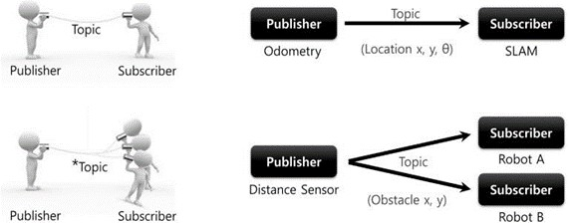

Figure 28 Topic Message Communication

#### Service

The service is synchronous bidirectional communication between the service client, which asks a service for a certain task, and the service server, which responds to requests.

#### Service Server

The ‘service server’ is a server in the service message communication that receives a request as an input and transmits a response as an output. Both request and response are in the form of messages.

#### Service Client

The ‘service client’ is a client in the service message communication that requests service to the server and receives a response as an input.

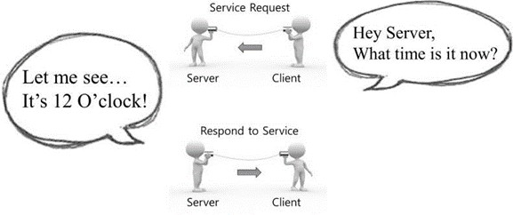

Figure 29 Service Message Communication

Another message communication mechanism for asynchronous bidirectional communication is action. When responding to a request takes longer than expected and intermediate answers are required before the result is returned, action is utilized. Action files have a similar structure to service files. However, along with the goal and outcome data sections, which are represented as request and response in service, a feedback data component for intermediate responses has been included. As **shown 29** The action client specifies the action's goal, and the action server executes the goal's action and delivers feedback and results to the action client. [6]

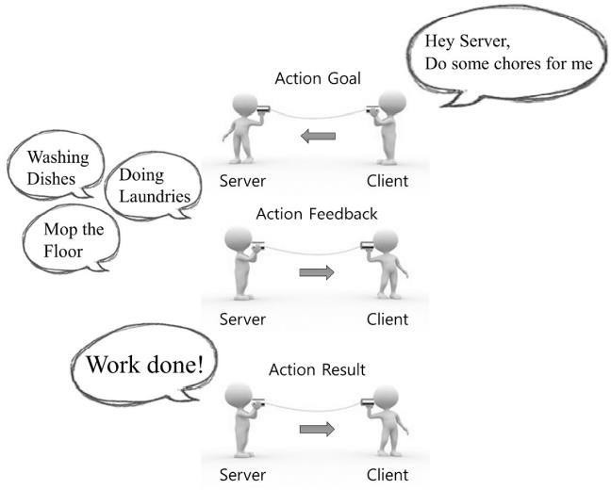

Figure 30 Action Message Communication

#### Parameter

It refers to parameter used in a node. You can think of it as a *.ini configuration file in windows programs. It has default values that can be read or written if necessary.

#### Catkin

Refers to the build system of ROS. The build system uses CMake (Cross Platform Make), and the build environment is described in the CMakeLists.txt file in the package folder.

#### Roscore

It is the command that runs the ROS master. It can be executed from another computer on the network if many computers are connected to it. Only one roscore should be running in the network, with the exception of special cases that support multiple roscore. The URI address and port number assigned to the ROS MASTER URI environment variables are used while ROS master is executing. If the user does not change the environment variable, the current local IP address is used as the URI address, and port 11311 is used as the master's default port.

#### *Rosrun:*

It is referred to as the basic execution command for ROS. It is used to run a single node in the package.

#### *Roslaunch:*

Compared to rosrun, roslaunch is used to run multiple nodes. roslaunch uses the ‘*.launch’ file to define which nodes to be executed. The file is based on XML (Extensible Markup Language) and offers a variety of options in the form of XML tags.

#### *ROS Wiki:*

Explains each package and the features provided by ROS.

## Message Communication

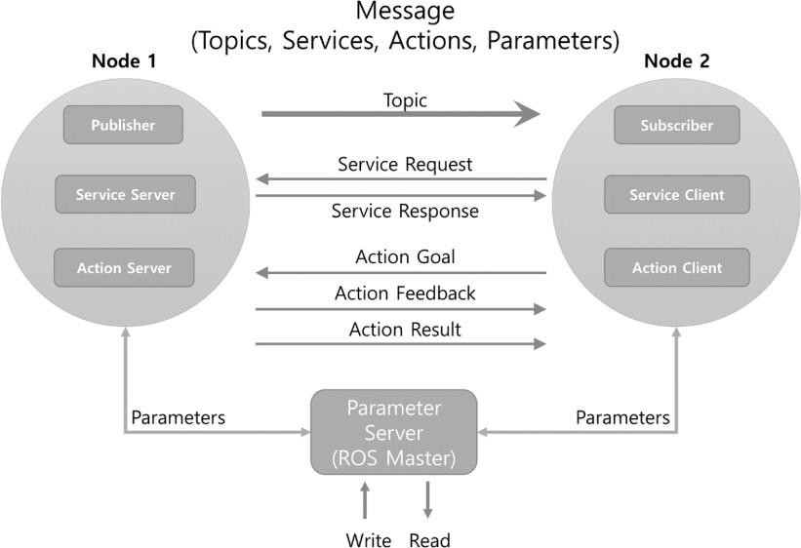

Figure 31 Message Communication Nodes

The publisher, the subscriber, the service server, the service client, the action server, and the action client can be implemented in separate nodes. The link between these nodes must first be created with the help of a master in order to exchange messages. As explained in **figure 32** A master functions similarly to a name server by storing node, topic, service, and action names, as well as the URI address, port number, and parameters. In other words, when nodes launch, they register their own information with the master and the master acquires relative information from other nodes. Then, for message communication, each node links directly to the others.

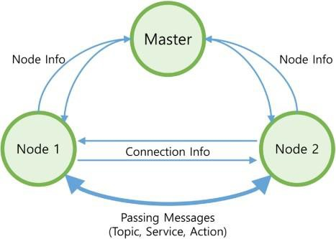

Figure 32 Message Communication

## ROS Tools

There are various tools that can helps us using ROS. It is usually installed with ROS-full. The tools we are going to go through do not directly process a function in the ROS, but they are greatly useful supplementary tools for programming with ROS.

* Rviz
* Rqt_gra p

### 3D Visualization Tool (Rviz)

RVIZ is a tool that allows you to visualize *Images, PointClouds, Lasers, Kinematic Transformations, RobotModels*...The list is endless. You even can define your own markers. It's one of the reasons why ROS got such a great acceptance. Before RVIZ, it was really difficult to know what the Robot was perceiving.

**And that's the main concept:**

RVIZ is **NOT** a simulation. I repeat: It's **NOT** a simulation.

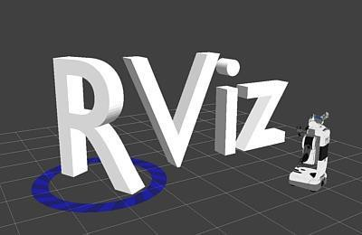RVIZ is a representation of what is being published in the topics, by the simulation or the real robot.

Figure 33 how to run rviz :

**Figure 4.15 Rviz**

rosrun rviz rvizyou will see a window like this.

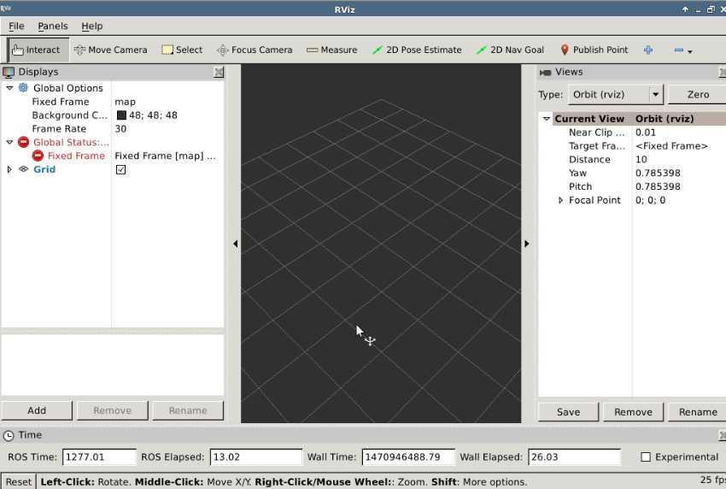

Figure 34 RViz example

### ROS GUI Tool (rqt)

ROS provides various GUI tools for robot development. For example, there is a graphical tool that shows the hierarchy of each node as a diagram thereby showing the status of the current node and topic.

Rqt_graph is a tool that shows the correlation among active nodes and messages being transmitted on the ROS network as a diagram. This is very useful for understanding the current structure of the ROS network. The diagram in **figure 35**

As an example, for the purpose of checking the nodes, let’s run ‘turtlesim_node’ and ‘turtle_teleop_key’ in the ‘turtlesim’ package, and the ‘uvc_camera_node’ in the ‘uvc_camera’ package. [8]

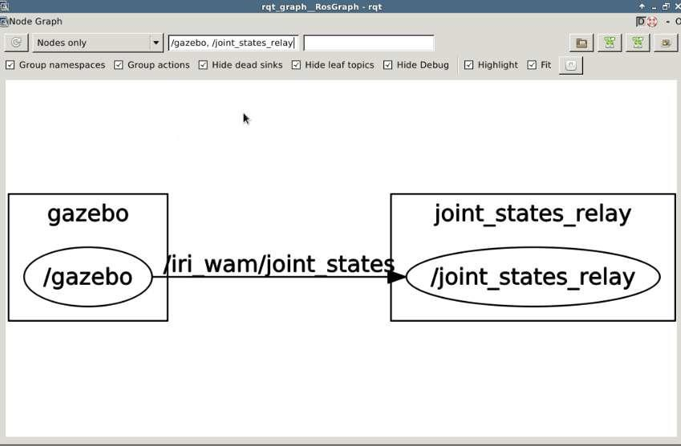

Figure 35 rqt_graph example

## yolo v2

YOLO v2: Real-Time Object Detection

YOLO v2 is a significant advancement in the field of real-time object detection, building on the strengths of its predecessor, YOLO v1, while introducing several enhancements to improve accuracy and performance. Developed by Joseph Redmon and Ali Farhadi, YOLO v2 offers a balanced approach to object detection that combines speed with accuracy, making it suitable for various applications ranging from surveillance to autonomous driving.

1. Unified Detection Model:

- YOLO v2 operates as a single neural network that processes the entire image at once, rather than using region proposals or sliding windows. This holistic approach allows for fast and efficient detection of objects within an image.

2. Improved Bounding Box Prediction

- YOLO v2 introduces anchor boxes, a technique that allows the network to predict bounding boxes with different aspect ratios and sizes. This improvement addresses the limitations of YOLO v1, where the network struggled with objects of varying scales and aspect ratios.

3. Batch Normalization:

- The use of batch normalization across the convolutional layers helps to stabilize and speed up the training process. It also acts as a regularizer, reducing the need for dropout and improving overall performance.

4. Higher Resolution Classifier:

- YOLO v2 utilizes a high-resolution classifier during training, which leads to more accurate detections. By first training the network on a higher resolution (e.g., 448x448 pixels) and then fine-tuning it on a lower resolution (e.g., 416x416 pixels), YOLO v2 achieves better detection accuracy without compromising speed.

5. Multi-Scale Training:

- Multi-scale training is another key enhancement in YOLO v2. The network is trained on images of varying resolutions, which makes it more robust and capable of handling different input sizes during inference.

6. Use of Darknet-19:

- YOLO v2 employs a new architecture called Darknet-19, consisting of 19 convolutional layers and 5 max-pooling layers. Darknet-19 is both lightweight and powerful, providing a good trade-off between computational complexity and detection accuracy.

7. Improved Detection Accuracy:

- With these enhancements, YOLO v2 achieves significant improvements in detection accuracy. It outperforms many contemporary real-time object detection frameworks, making it a preferred choice for applications requiring both speed and accuracy.

**Applications**

- Autonomous Vehicles:

YOLO v2's real-time capabilities make it ideal for use in autonomous driving systems, where quick and accurate detection of pedestrians, vehicles, and obstacles is critical for safe navigation.

- Surveillance and Security:

In security applications, YOLO v2 can be used for monitoring live feeds, detecting suspicious activities, and identifying unauthorized objects or individuals in restricted areas.

- Robotics:

YOLO v2 is employed in various robotic systems for tasks such as object manipulation, navigation, and interaction with the environment.

## simulation

* **Model.sdf**

**<?xml version="1.0" ?>**

**<sdf version="1.5">**

**<model name="turtlebot3_burger">**

**<link name="base">**

**<inertial>**

**<pose>-0.032 0 0.070 0 0 0</pose>**

**<inertia>**

**<ixx>0.001</ixx>**

**<ixy>0.000</ixy>**

**<ixz>0.000</ixz>**

**<iyy>0.001</iyy>**

**<iyz>0.000</iyz>**

**<izz>0.001</izz>**

**</inertia>**

**<mass>1.0</mass>**

**</inertial>**

**<collision name="base_collision">**

**<pose>-0.032 0 0.070 0 0 0</pose>**

**<geometry>**

**<box>**

**<size>0.140 0.140 0.140</size>**

**</box>**

**</geometry>**

**</collision>**

**<visual name="base_visual">**

**<pose>-0.032 0 0 0 0 0</pose>**

**<geometry>**

**<mesh>**

**<uri>model://turtlebot3_common_meshes/burger_base.dae</uri>**

**<scale>0.001 0.001 0.001</scale>**

**</mesh>**

**</geometry>**

**</visual>**

**<collision name="caster_collision">**

**<pose>-0.081 0 -0.004 0 0 0</pose>**

**<geometry>**

**<sphere>**

**<radius>0.005000</radius>**

**</sphere>**

**</geometry>**

**<surface>**

**<friction>**

**<ode>**

**<mu>100000.0</mu>**

**<mu2>100000.0</mu2>**

**<fdir1>0 0 0</fdir1>**

**<slip1>0</slip1>**

**<slip2>0</slip2>**

**</ode>**

**</friction>**

**</surface>**

**</collision>**

**</link>**

**<link name="lidar">**

**<inertial>**

**<pose>-0.020 0 0.161 0 0 0</pose>**

**<inertia>**

**<ixx>0.001</ixx>**

**<ixy>0.000</ixy>**

**<ixz>0.000</ixz>**

**<iyy>0.001</iyy>**

**<iyz>0.000</iyz>**

**<izz>0.001</izz>**

**</inertia>**

**<mass>0.125</mass>**

**</inertial>**

**<collision name="lidar_sensor_collision">**

**<pose>-0.020 0 0.161 0 0 0</pose>**

**<geometry>**

**<cylinder>**

**<radius>0.0508</radius>**

**<length>0.055</length>**

**</cylinder>**

**</geometry>**

**</collision>**

**<visual name="lidar_sensor_visual">**

**<pose>-0.032 0 0.171 0 0 0</pose>**

**<geometry>**

**<mesh>**

**<uri>model://turtlebot3_common_meshes/lds.dae</uri>**

**<scale>0.001 0.001 0.001</scale>**

**</mesh>**

**</geometry>**

**</visual>**

**<sensor name="hls_lfcd_lds" type="ray">**

**<always_on>1</always_on>**

**<visualize>0</visualize>**

**<pose>-0.032 0 0.171 0 0 0</pose>**

**<update_rate>1800</update_rate>**

**<ray>**

**<scan>**

**<horizontal>**

**<samples>360</samples>**

**<resolution>1.000000</resolution>**

**<min_angle>0.000000</min_angle>**

**<max_angle>6.280000</max_angle>**

**</horizontal>**

**</scan>**

**<range>**

**<min>0.120000</min>**

**<max>3.5</max>**

**<resolution>0.015000</resolution>**

**</range>**

**<noise>**

**<type>gaussian</type>**

**<mean>0.0</mean>**

**<stddev>0.01</stddev>**

**</noise>**

**</ray>**

**</sensor>**

**</link>**

**<link name="left_wheel">**

**<inertial>**

**<pose>0 0.08 0.023 -1.57 0 0</pose>**

**<inertia>**

**<ixx>0.001</ixx>**

**<ixy>0.000</ixy>**

**<ixz>0.000</ixz>**

**<iyy>0.001</iyy>**

**<iyz>0.000</iyz>**

**<izz>0.001</izz>**

**</inertia>**

**<mass>0.1</mass>**

**</inertial>**

**<collision name="left_wheel_collision">**

**<pose>0 0.08 0.023 -1.57 0 0</pose>**

**<geometry>**

**<cylinder>**

**<radius>0.033</radius>**

**<length>0.018</length>**

**</cylinder>**

**</geometry>**

**<surface>**

**<!-- This friction pamareter don't contain reliable data!! -->**

**<friction>**

**<ode>**

**<mu>100000.0</mu>**

**<mu2>100000.0</mu2>**

**<fdir1>0 0 0</fdir1>**

**<slip1>0.0</slip1>**

**<slip2>0.0</slip2>**

**</ode>**

**</friction>**

**</surface>**

**</collision>**

**<visual name="left_wheel_visual">**

**<pose>0 0.08 0.023 0 0 0</pose>**

**<geometry>**

**<mesh>**

**<uri>model://turtlebot3_common_meshes/tire.dae</uri>**

**<scale>0.001 0.001 0.001</scale>**

**</mesh>**

**</geometry>**

**</visual>**

**</link>**

**<link name="right_wheel">**

**<inertial>**

**<pose>0.0 -0.08 0.023 -1.57 0 0</pose>**

**<inertia>**

**<ixx>0.001</ixx>**

**<ixy>0.000</ixy>**

**<ixz>0.000</ixz>**

**<iyy>0.001</iyy>**

**<iyz>0.000</iyz>**

**<izz>0.001</izz>**

**</inertia>**

**<mass>0.1</mass>**

**</inertial>**

**<collision name="right_wheel_collision">**

**<pose>0.0 -0.08 0.023 -1.57 0 0</pose>**

**<geometry>**

**<cylinder>**

**<radius>0.033</radius>**

**<length>0.018</length>**

**</cylinder>**

**</geometry>**

**<surface>**

**<!-- This friction pamareter don't contain reliable data!! -->**

**<friction>**

**<ode>**

**<mu>100000.0</mu>**

**<mu2>100000.0</mu2>**

**<fdir1>0 0 0</fdir1>**

**<slip1>0.0</slip1>**

**<slip2>0.0</slip2>**

**</ode>**

**</friction>**

**</surface>**

**</collision>**

**<visual name="right_wheel_visual">**

**<pose>0.0 -0.08 0.023 0 0 0</pose>**

**<geometry>**

**<mesh>**

**<uri>model://turtlebot3_common_meshes/tire.dae</uri>**

**<scale>0.001 0.001 0.001</scale>**

**</mesh>**

**</geometry>**

**</visual>**

**</link>**

**<joint name="left_wheel_joint" type="revolute">**

**<parent>base</parent>**

**<child>left_wheel</child>**

**<pose>0.0 0.08 0.023 -1.57 0 0</pose>**

**<axis>**

**<xyz>0 1 0</xyz>**

**</axis>**

**</joint>**

**<joint name="right_wheel_joint" type="revolute">**

**<parent>base</parent>**

**<child>right_wheel</child>**

**<pose>0.0 -0.08 0.023 -1.57 0 0</pose>**

**<axis>**

**<xyz>0 1 0</xyz>**

**</axis>**

**</joint>**

**<joint name="lidar_joint" type="fixed">**

**<parent>base</parent>**

**<child>lidar</child>**

**<pose>-0.032 0 0.171 0 0 0</pose>**

**<axis>**

**<xyz>0 0 1</xyz>**

**<use_parent_model_frame>true</use_parent_model_frame>**

**</axis>**

**</joint>**

**<static>0</static>**

**</model>**

**</sdf>**

* **Turtlebot3_house. launch**

**<launch>**

**<arg name="model" default="$(env TURTLEBOT3_MODEL)" doc="model type [burger, waffle, waffle_pi]"/>**

**<arg name="x_pos" default="-3.0"/>**

**<arg name="y_pos" default="1.0"/>**

**<arg name="z_pos" default="0.0"/>**

**<include file="$(find gazebo_ros)/launch/empty_world.launch">**

**<arg name="world_name" value="$(find turtlebot3_gazebo)/worlds/turtlebot3_house.world"/>**

**<arg name="paused" value="false"/>**

**<arg name="use_sim_time" value="true"/>**

**<arg name="gui" value="true"/>**

**<arg name="headless" value="false"/>**

**<arg name="debug" value="false"/>**

**</include>**

**<param name="robot_description" command="$(find xacro)/xacro --inorder $(find turtlebot3_description)/urdf/turtlebot3_$(arg model).urdf.xacro" />**

**<node name="spawn_urdf" pkg="gazebo_ros" type="spawn_model" args="-urdf -model turtlebot3 -x $(arg x_pos) -y $(arg y_pos) -z $(arg z_pos) -param robot_description" />**

**</launch>**

* **Turtlebot3. launch**

<launch>

<arg name="model" default="$(env TURTLEBOT3_MODEL)" doc="model type [burger, waffle, waffle_pi]"/>

<param name="tb3_model" value="$(arg model)"/>

<include file="$(find turtlebot3_bringup)/launch/includes/description.launch.xml">

<arg name="model" value="$(arg model)" />

</include>

<node pkg="turtlebot3_fake" type="turtlebot3_fake_node" name="turtlebot3_fake_node" output="screen" />

<node pkg="robot_state_publisher" type="robot_state_publisher" name="robot_state_publisher" output="screen">

<param name="publish_frequency" type="double" value="50.0" />

</node>

<node name="rviz" pkg="rviz" type="rviz" args="-d $(find turtlebot3_fake)/rviz/turtlebot3_fake.rviz"/>

</launch>

Turtlebot3_drive

/*******************************************************************************

* Copyright 2016 ROBOTIS CO., LTD.

*

* Licensed under the Apache License, Version 2.0 (the "License");

* you may not use this file except in compliance with the License.

* You may obtain a copy of the License at

*

* http://www.apache.org/licenses/LICENSE-2.0

*

* Unless required by applicable law or agreed to in writing, software

* distributed under the License is distributed on an "AS IS" BASIS,

* WITHOUT WARRANTIES OR CONDITIONS OF ANY KIND, either express or implied.

* See the License for the specific language governing permissions and

* limitations under the License.

*******************************************************************************/

/* Authors: Yoonseok Pyo */

#include <turtlebot3_fake/turtlebot3_fake.h>

Turtlebot3Fake::Turtlebot3Fake()

: nh_priv_("~")

{

//Init fake turtlebot node

bool init_result = init();

ROS_ASSERT(init_result);

}

Turtlebot3Fake::~Turtlebot3Fake()

{

}

/*******************************************************************************

* Init function

*******************************************************************************/

bool Turtlebot3Fake::init()

{

// initialize ROS parameter

std::string robot_model = nh_.param<std::string>("tb3_model", "");

if (!robot_model.compare("burger"))

{

wheel_seperation_ = 0.160;

turning_radius_ = 0.080;

robot_radius_ = 0.105;

}

else if (!robot_model.compare("waffle") || !robot_model.compare("waffle_pi"))

{

wheel_seperation_ = 0.287;

turning_radius_ = 0.1435;

robot_radius_ = 0.220;

}

nh_.param("wheel_left_joint_name", joint_states_name_[LEFT], std::string("wheel_left_joint"));

nh_.param("wheel_right_joint_name", joint_states_name_[RIGHT], std::string("wheel_right_joint"));

nh_.param("joint_states_frame", joint_states_.header.frame_id, std::string("base_footprint"));

nh_.param("odom_frame", odom_.header.frame_id, std::string("odom"));

nh_.param("base_frame", odom_.child_frame_id, std::string("base_footprint"));

// initialize variables

wheel_speed_cmd_[LEFT] = 0.0;

wheel_speed_cmd_[RIGHT] = 0.0;

goal_linear_velocity_ = 0.0;

goal_angular_velocity_ = 0.0;

cmd_vel_timeout_ = 1.0;

last_position_[LEFT] = 0.0;

last_position_[RIGHT] = 0.0;

last_velocity_[LEFT] = 0.0;

last_velocity_[RIGHT] = 0.0;

double pcov[36] = { 0.1, 0, 0, 0, 0, 0,

0, 0.1, 0, 0, 0, 0,

0, 0, 1e6, 0, 0, 0,

0, 0, 0, 1e6, 0, 0,

0, 0, 0, 0, 1e6, 0,

0, 0, 0, 0, 0, 0.2};

memcpy(&(odom_.pose.covariance),pcov,sizeof(double)*36);

memcpy(&(odom_.twist.covariance),pcov,sizeof(double)*36);

odom_pose_[0] = 0.0;

odom_pose_[1] = 0.0;

odom_pose_[2] = 0.0;

odom_vel_[0] = 0.0;

odom_vel_[1] = 0.0;

odom_vel_[2] = 0.0;

joint_states_.name.push_back(joint_states_name_[LEFT]);

joint_states_.name.push_back(joint_states_name_[RIGHT]);

joint_states_.position.resize(2,0.0);

joint_states_.velocity.resize(2,0.0);

joint_states_.effort.resize(2,0.0);

// initialize publishers

joint_states_pub_ = nh_.advertise<sensor_msgs::JointState>("joint_states", 100);

odom_pub_ = nh_.advertise<nav_msgs::Odometry>("odom", 100);

// initialize subscribers

cmd_vel_sub_ = nh_.subscribe("cmd_vel", 100, &Turtlebot3Fake::commandVelocityCallback, this);

prev_update_time_ = ros::Time::now();

return true;

}

/*******************************************************************************

* Callback function for cmd_vel msg

*******************************************************************************/

void Turtlebot3Fake::commandVelocityCallback(const geometry_msgs::TwistConstPtr cmd_vel_msg)

{

last_cmd_vel_time_ = ros::Time::now();

goal_linear_velocity_ = cmd_vel_msg->linear.x;

goal_angular_velocity_ = cmd_vel_msg->angular.z;

wheel_speed_cmd_[LEFT] = goal_linear_velocity_ - (goal_angular_velocity_ * wheel_seperation_ / 2);

wheel_speed_cmd_[RIGHT] = goal_linear_velocity_ + (goal_angular_velocity_ * wheel_seperation_ / 2);

}

/*******************************************************************************

* Calculate the odometry

*******************************************************************************/

bool Turtlebot3Fake::updateOdometry(ros::Duration diff_time)

{

double wheel_l, wheel_r; // rotation value of wheel [rad]

double delta_s, delta_theta;

double v[2], w[2];

wheel_l = wheel_r = 0.0;

delta_s = delta_theta = 0.0;

v[LEFT] = wheel_speed_cmd_[LEFT];

w[LEFT] = v[LEFT] / WHEEL_RADIUS; // w = v / r

v[RIGHT] = wheel_speed_cmd_[RIGHT];

w[RIGHT] = v[RIGHT] / WHEEL_RADIUS;

last_velocity_[LEFT] = w[LEFT];

last_velocity_[RIGHT] = w[RIGHT];

wheel_l = w[LEFT] * diff_time.toSec();

wheel_r = w[RIGHT] * diff_time.toSec();

if(isnan(wheel_l))

{

wheel_l = 0.0;

}

if(isnan(wheel_r))

{

wheel_r = 0.0;

}

last_position_[LEFT] += wheel_l;

last_position_[RIGHT] += wheel_r;

delta_s = WHEEL_RADIUS * (wheel_r + wheel_l) / 2.0;

delta_theta = WHEEL_RADIUS * (wheel_r - wheel_l) / wheel_seperation_;

// compute odometric pose

odom_pose_[0] += delta_s * cos(odom_pose_[2] + (delta_theta / 2.0));

odom_pose_[1] += delta_s * sin(odom_pose_[2] + (delta_theta / 2.0));

odom_pose_[2] += delta_theta;

// compute odometric instantaneouse velocity

odom_vel_[0] = delta_s / diff_time.toSec(); // v

odom_vel_[1] = 0.0;

odom_vel_[2] = delta_theta / diff_time.toSec(); // w

odom_.pose.pose.position.x = odom_pose_[0];

odom_.pose.pose.position.y = odom_pose_[1];

odom_.pose.pose.position.z = 0;

odom_.pose.pose.orientation = tf::createQuaternionMsgFromYaw(odom_pose_[2]);

// We should update the twist of the odometry

odom_.twist.twist.linear.x = odom_vel_[0];

odom_.twist.twist.angular.z = odom_vel_[2];

return true;

}

/*******************************************************************************

* Calculate the joint states

*******************************************************************************/

void Turtlebot3Fake::updateJoint(void)

{

joint_states_.position[LEFT] = last_position_[LEFT];

joint_states_.position[RIGHT] = last_position_[RIGHT];

joint_states_.velocity[LEFT] = last_velocity_[LEFT];

joint_states_.velocity[RIGHT] = last_velocity_[RIGHT];

}

/*******************************************************************************

* Calculate the TF

*******************************************************************************/

void Turtlebot3Fake::updateTF(geometry_msgs::TransformStamped& odom_tf)

{

odom_tf.header = odom_.header;

odom_tf.child_frame_id = odom_.child_frame_id;

odom_tf.transform.translation.x = odom_.pose.pose.position.x;

odom_tf.transform.translation.y = odom_.pose.pose.position.y;

odom_tf.transform.translation.z = odom_.pose.pose.position.z;

odom_tf.transform.rotation = odom_.pose.pose.orientation;

}

/*******************************************************************************

* Update function

*******************************************************************************/

bool Turtlebot3Fake::update()

{

ros::Time time_now = ros::Time::now();

ros::Duration step_time = time_now - prev_update_time_;

prev_update_time_ = time_now;

// zero-ing after timeout

if((time_now - last_cmd_vel_time_).toSec() > cmd_vel_timeout_)

{

wheel_speed_cmd_[LEFT] = 0.0;

wheel_speed_cmd_[RIGHT] = 0.0;

}

// odom

updateOdometry(step_time);

odom_.header.stamp = time_now;

odom_pub_.publish(odom_);

// joint_states

updateJoint();

joint_states_.header.stamp = time_now;

joint_states_pub_.publish(joint_states_);

// tf

geometry_msgs::TransformStamped odom_tf;

updateTF(odom_tf);

tf_broadcaster_.sendTransform(odom_tf);

return true;

}

/*******************************************************************************

* Main function

*******************************************************************************/

int main(int argc, char* argv[])

{

ros::init(argc, argv, "turtlebot3_fake_node");

Turtlebot3Fake tb3fake;

ros::Rate loop_rate(30);

while (ros::ok())

{

tb3fake.update();

ros::spinOnce();

loop_rate.sleep();

}

return 0;

}

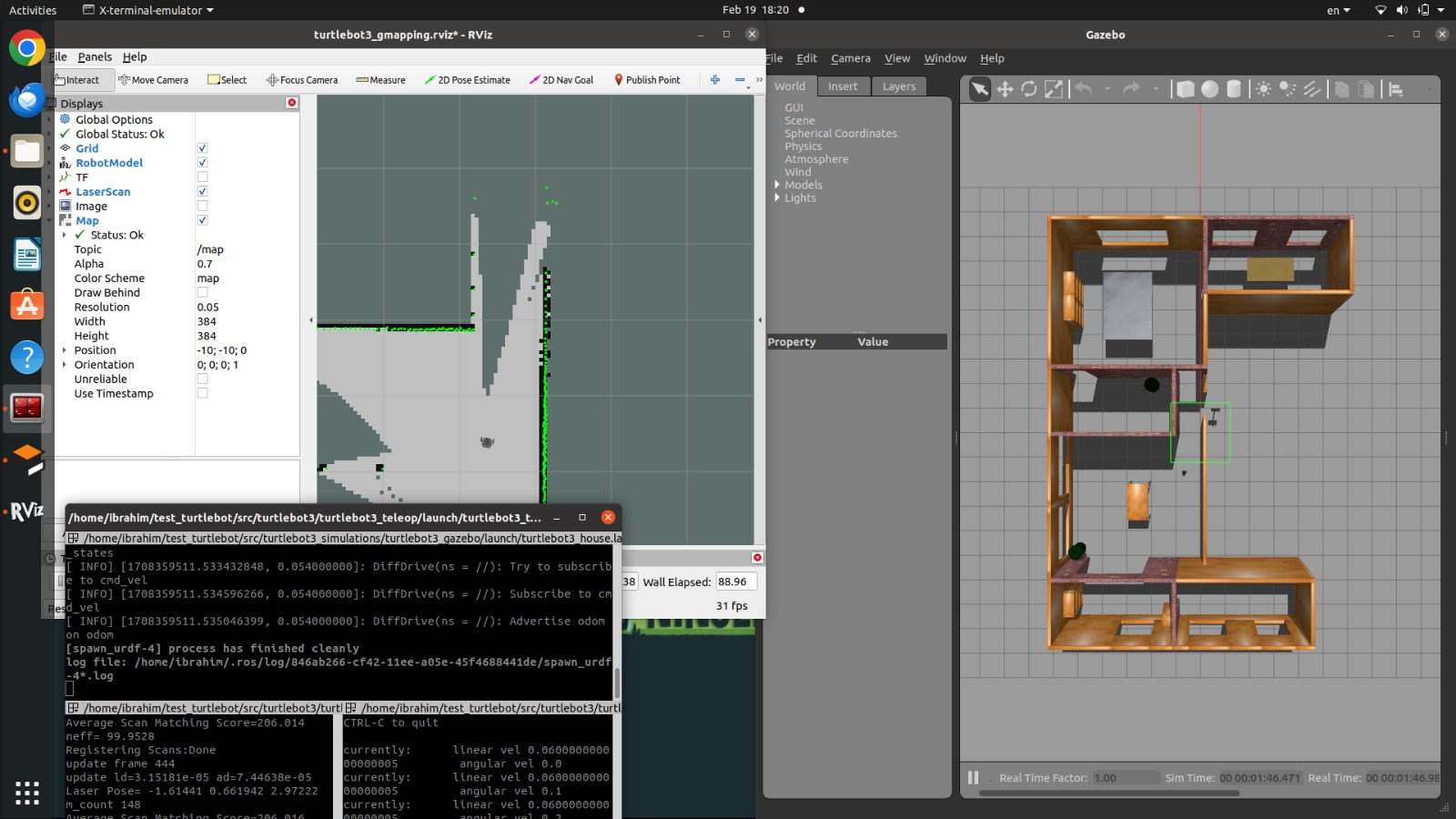

Figure 36: simulation in rviz & gazebo

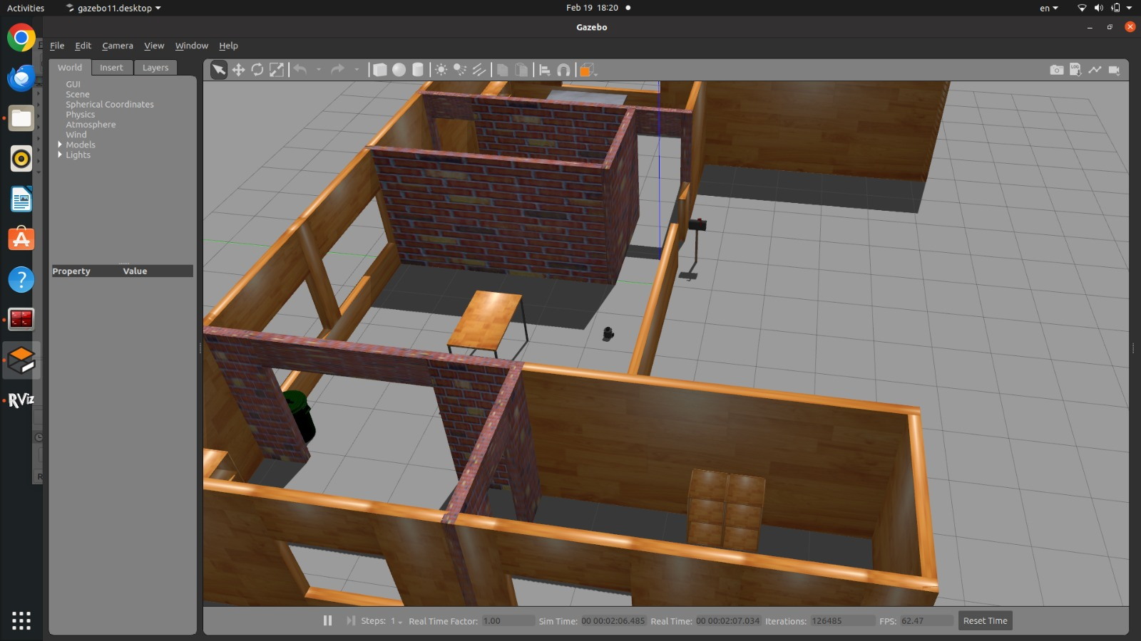

Figure 41: world in gazebo

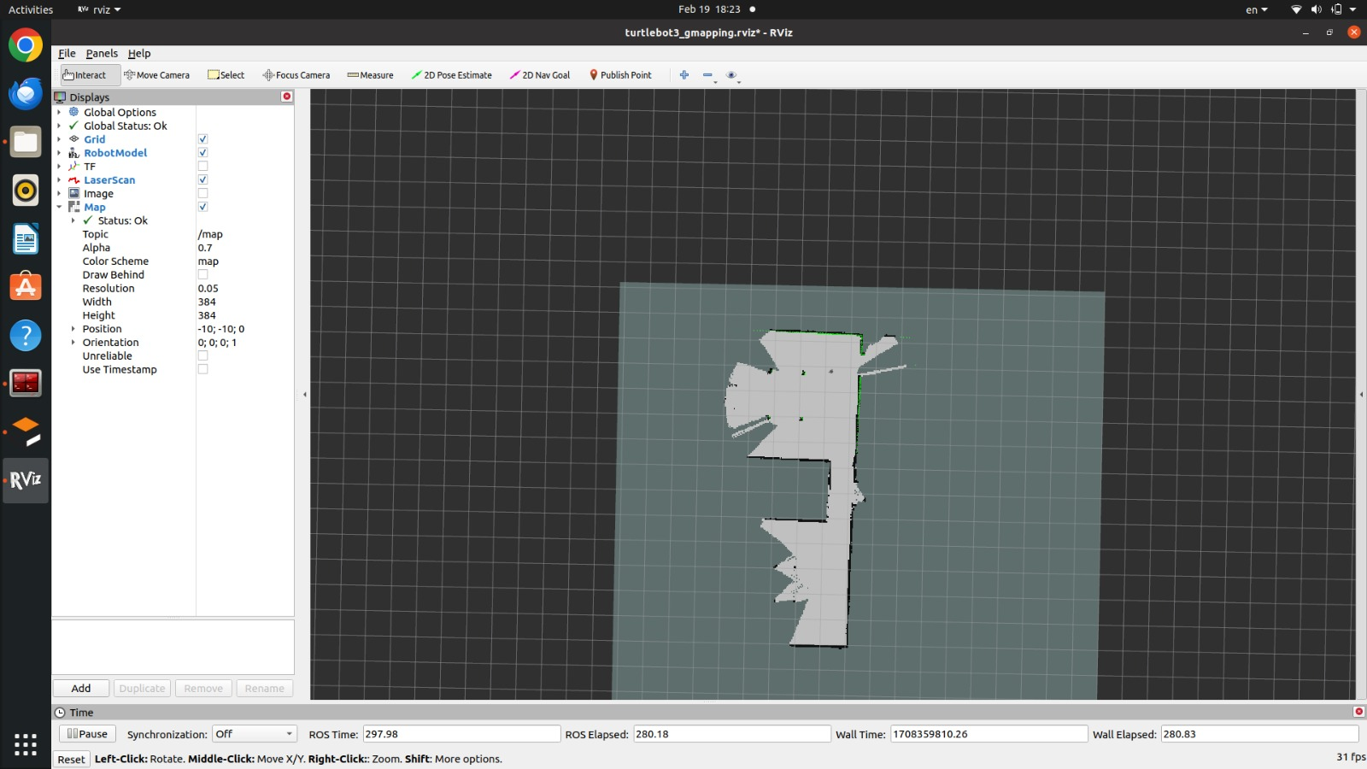

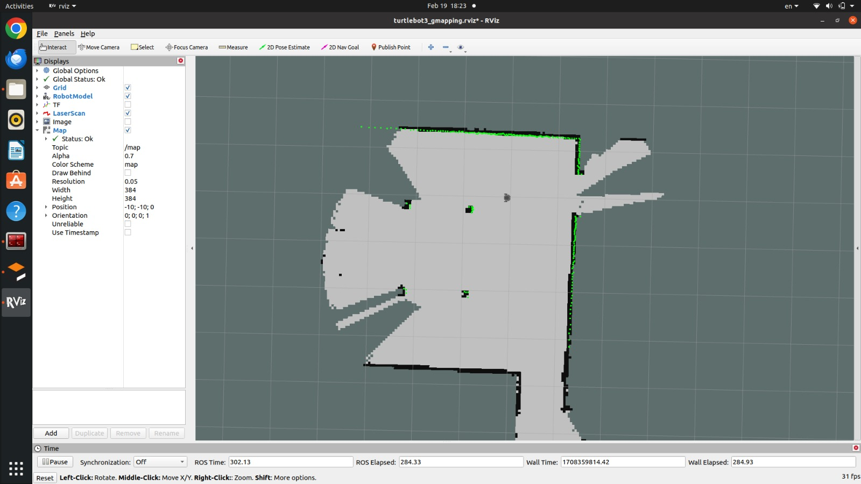

Figure 372 : Lidar mapping

# chapter4:

# Experiential work

The Chase Is Made From Aluminium Sheet Metal In Daltey CNC Factor In 10th Of Ramdan We Choose The Aluminium And With CNC Machines We Forms The Final Shape Of It . as showen in next **figures**

# matrial selection:

Aluminum is a widely used metal known for its unique properties that make it valuable in various manufacturing applications.

**Properties of Aluminum:**

* **Lightweight:** Compared to other metals like steel, aluminum is significantly lighter. This makes it ideal for applications where weight reduction is crucial, such as airplanes and automobiles.
* **Strength:** While lightweight, aluminum can be surprisingly strong, especially when alloyed with other elements. Different aluminum alloys offer varying degrees of strength for specific uses.
* **Ductility and Malleability:** Aluminum is easily shaped and formed, making it versatile for manufacturing processes like extrusion, rolling, and forging.
* **Corrosion Resistance:** Aluminum naturally forms a protective oxide layer that resists corrosion. This makes it suitable for applications exposed to the elements.
* **Conductivity:** Aluminum is a good conductor of heat and electricity, making it valuable for heat sinks, electrical wiring, and cookware.

**Implementation of Aluminum:**

Due to its beneficial properties, aluminum finds application across various industries:

* **Transportation:** Aluminum is a key material in car bodies, airplane fuselages, ships, and bicycles due to its lightweight strength.
* **Construction:** Aluminum is used for building facades, window frames, roofing, and even some structural components due to its strength and corrosion resistance.
* **Packaging:** Beverage cans, food containers, and aluminum foil all utilize aluminum for its formability, lightweight nature, and barrier properties.
* **Consumer Goods:** Aluminum is used in electronics (laptop cases, heat sinks), appliances, furniture, and sporting goods due to its versatility.

**Implementation Methods:**

Aluminum can be implemented through various manufacturing processes depending on the desired final product shape:

* **Extrusion:** Molten aluminum is forced through a die to create long, continuous shapes like tubes, pipes, and frames.
* **Rolling:** Aluminum is flattened into sheets and coils of various thicknesses through a rolling mill. These sheets are used for building materials, food packaging, and other applications.
* **Forging:** Aluminum is shaped by applying high pressure in a mold to create complex, high-strength components like engine parts.
* **Casting:** Molten aluminum is poured into a mold to create specific shapes, used for engine blocks, wheels, and other intricate parts.

By understanding the properties and implementation methods of aluminum, manufacturers can leverage this versatile material to create lightweight, durable, and functional products across various industries.

## ROBOT PHOTOS

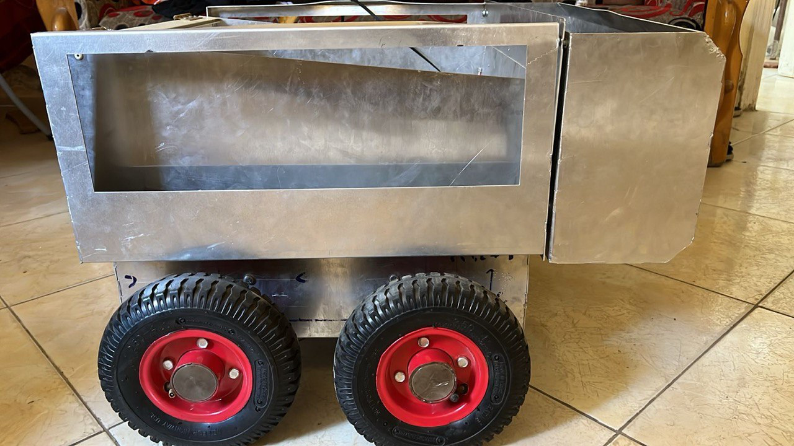

Figure 38 SIDE VIEW OF ABCC



Figure 39 SIDE VIEW EITHOUT TRACH BOX



Figure 40 ROBOT FRONT VIEW

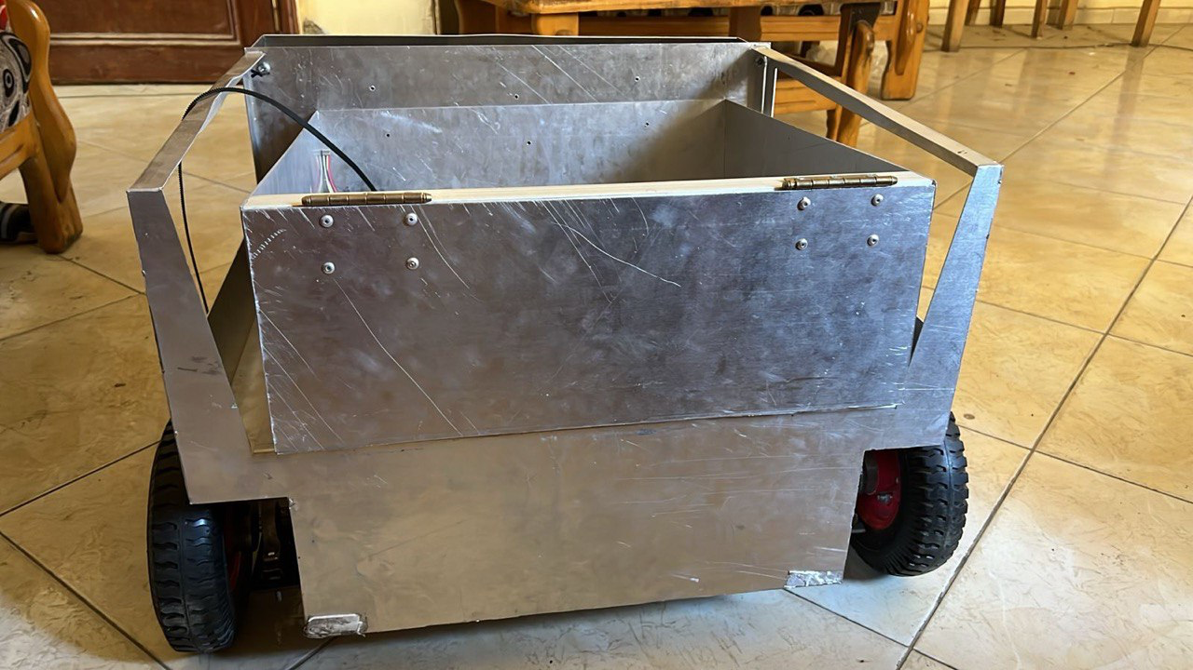

Figure 41 ROBOT BACK VIEW

## CONTROL UNIT

Figure 42 CONTROL UNIT

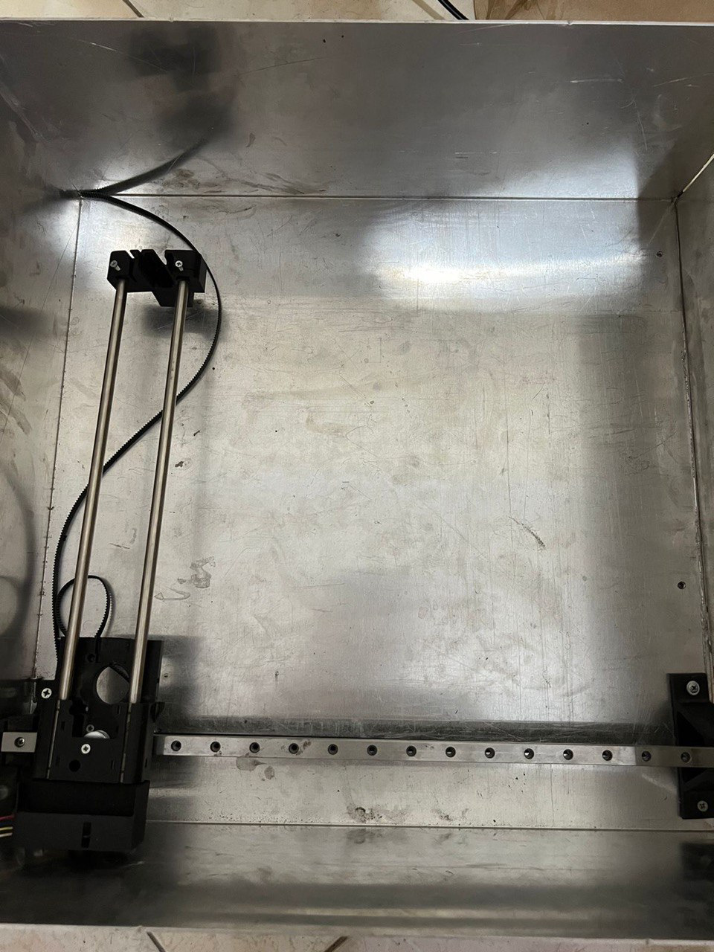

Figure 43 BOX WITH MECHANISM FOR MOVING THE TRACH

## dc MOTOR

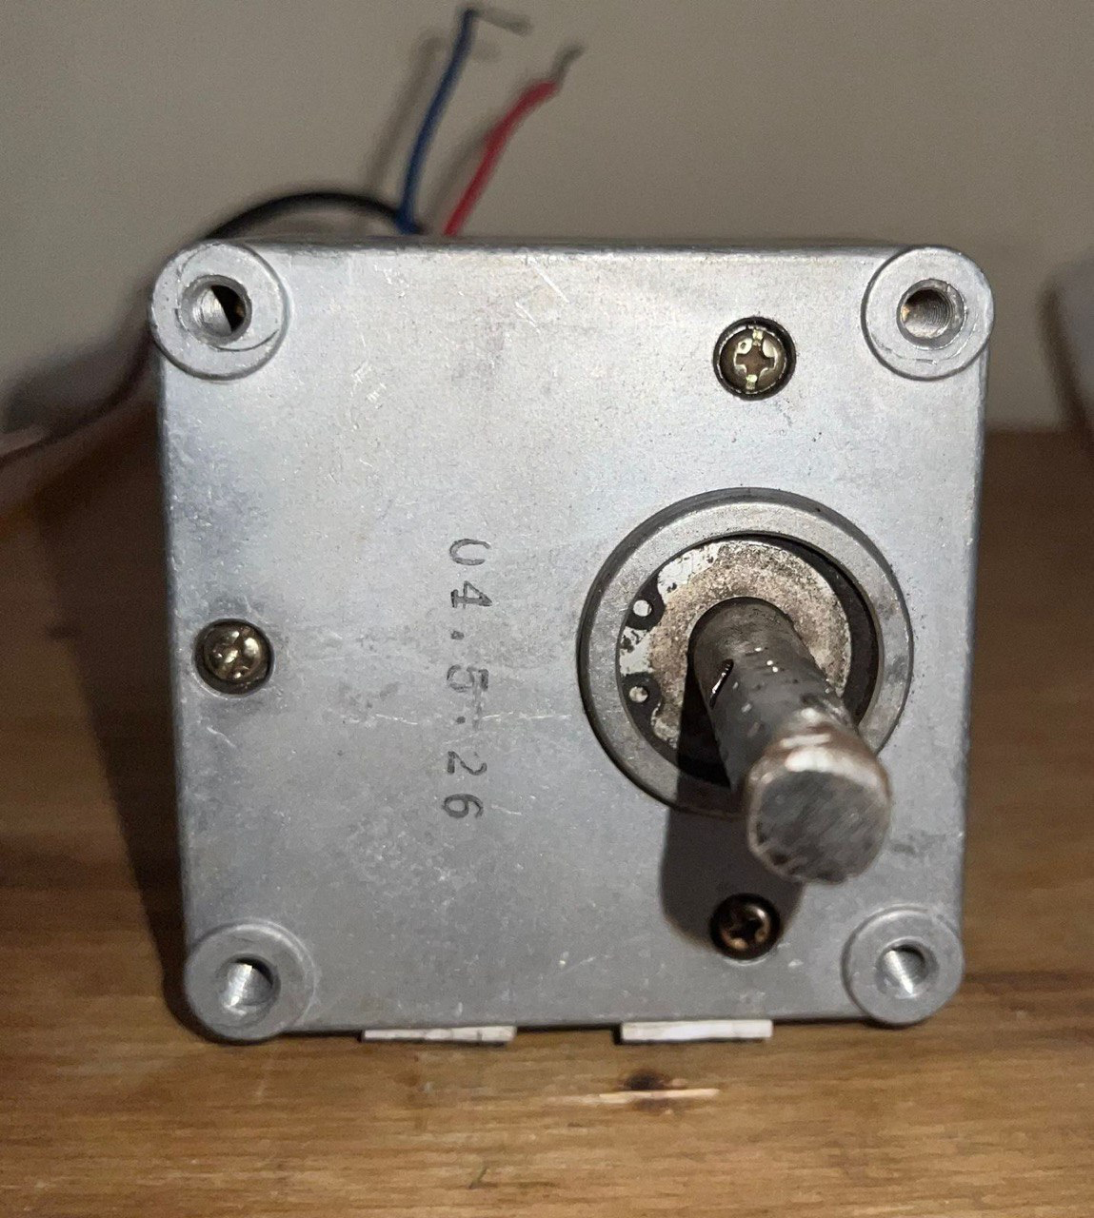

Figure 44 DC MOTOR FRONT VIEW

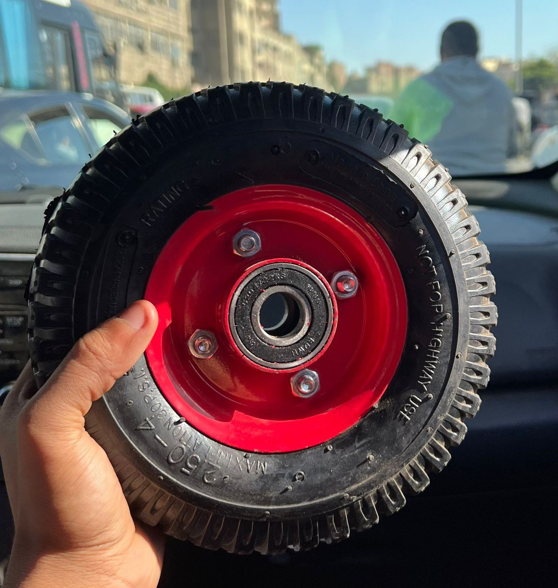

Figure 45 TIERS

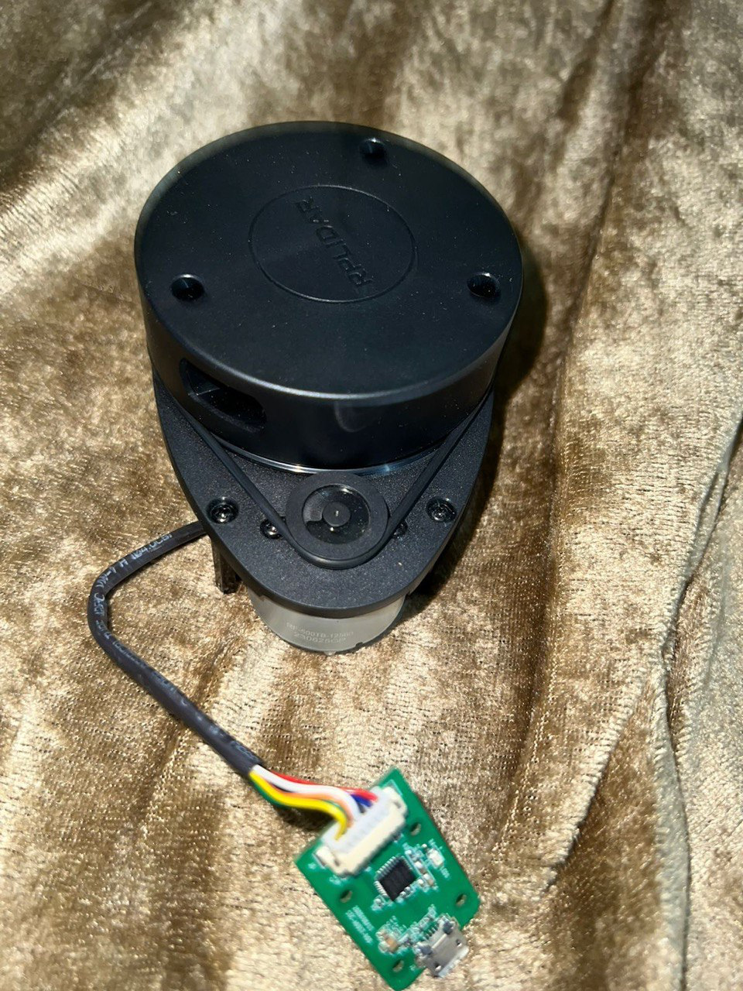

Figure 46 LIDAR A1

# references

1. Kim, Y. C., Han, J. H., & Lee, J. (2023, November). Practical and Rapid Motor Sizing Technique Using Existing Electrical Motor. In Actuators (Vol. 12, No. 12, p. 430). MDPI.‏
2. Wu, S., Fan, W., & Cui, S. (2014, August). Sizing equations suitable for driving motor initial design. In 2014 IEEE Conference and Expo Transportation Electrification Asia-Pacific (ITEC Asia-Pacific) (pp. 1-3). IEEE.‏
3. Sathish, S., & Harini, U. C. BEACH-CLEANING ROBOT DRIVES POLLUTION-FIGHTING INTO THE FUTURE.
4. ALeniziI, N. F., Alajmi, O. K., Alsharhan, S. A., & Khudada, S. T. (2019). Autonomous Beach Cleaner.‏
5. J. Redmon, S. K. Divvala, R. B. Girshick and A. Farhadi, "You Only Look Once: Unified, Real-Time Object Detection," in Proceedings of the IEEE conference on computer vision and pattern recognition,2016, pp.779-788.[Online].Available: https://openaccess.thecvf.com/content_cvpr_2016/html/Redmon_You_Only_Look_CVPR_2016_paper. html
6. Development of an Autonomous Beach Cleaning Robot (Mobile Manipulation Robot), 2013, The Proceedings of JSME annual Conference on Robotics and Mechatronics (Robomec), Shin-ichi NAKAJIMA, Yuusuke SAKURAI, Naofumi KOMAGATA, Masumi YOSHIDA, Tomoyasu ICHIMURA.
7. Semi automated wireless beach cleaning robot vehicle, 2019, 22773878, International Journal of Recent Technology and Engineering vol 8 issue 1, M. Bhavani, S. Kalaiselvan, S. Jagan, S. Gopinath.
8. S. K. Cho, J. Lee, K. J. Kim, S. I. Lee and K. J. Kim, "Development of an unmanned cleaning system for sandy beaches," IEEE/ASME Transactions on Mechatronics, vol. 11, no. 6, pp. 716-724, 2006. [Online].Available: <https://ieeexplore.ieee.org/document/4033677>
9. (2020, July 28). *Beach Cleaning Robot (garbage Collector) !!* Instructables. https://www.instructables.com/Beach-Cleaning-Robot-garbage-Collector-/

# APPENDICES

#### Appendix.A:SolidWorks analysis.

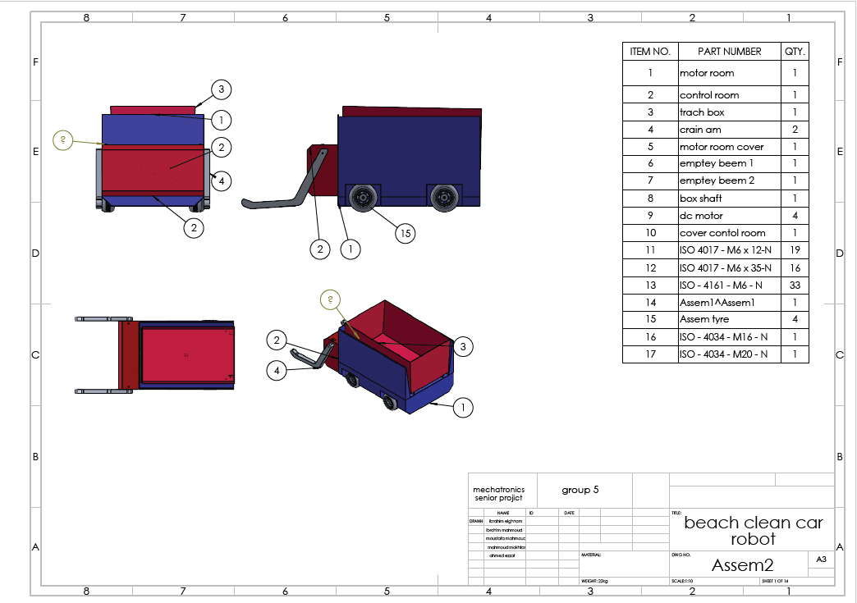

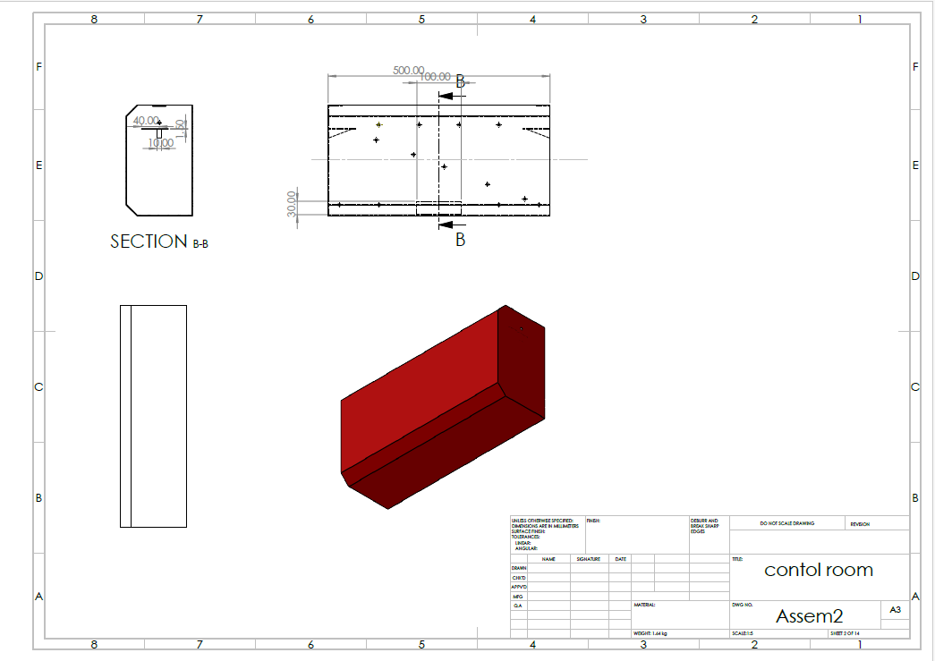

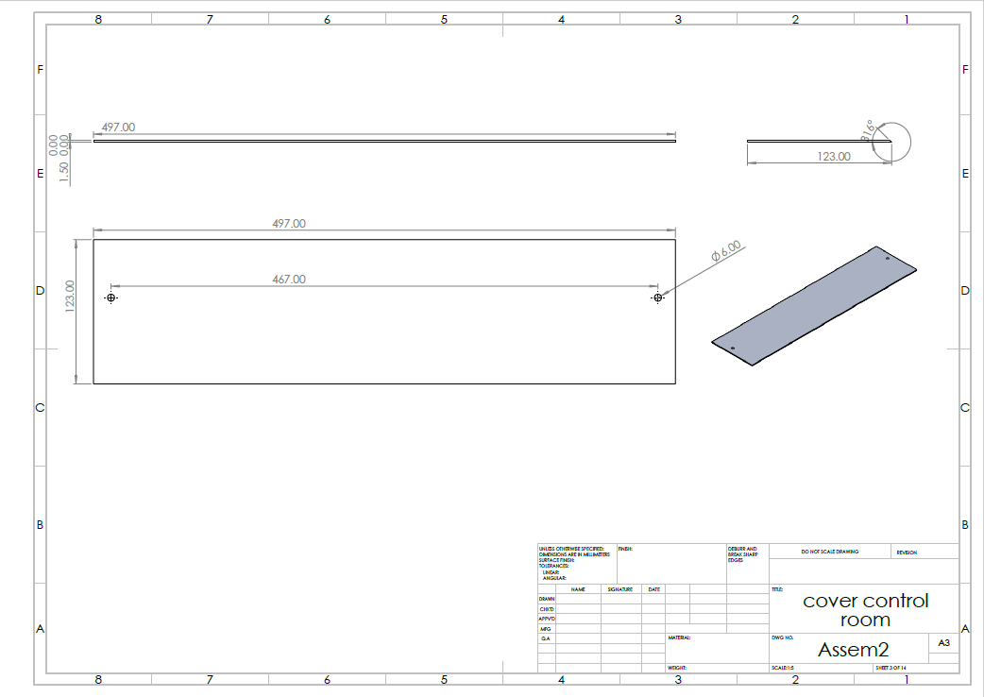

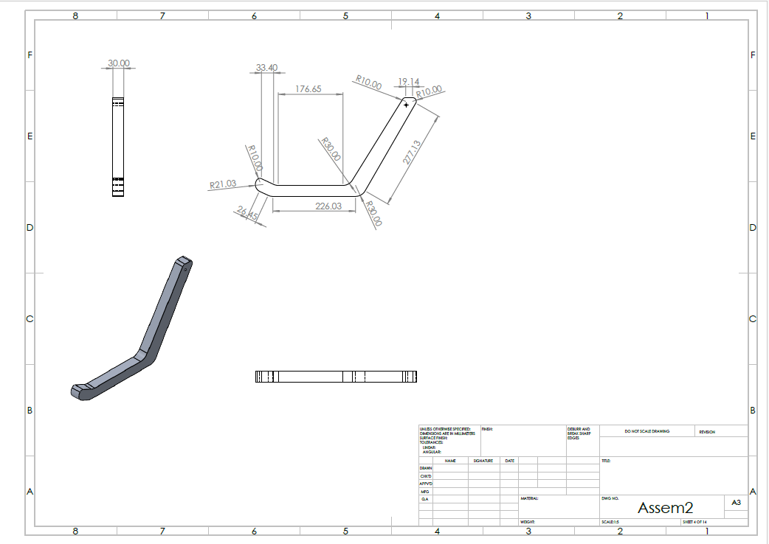

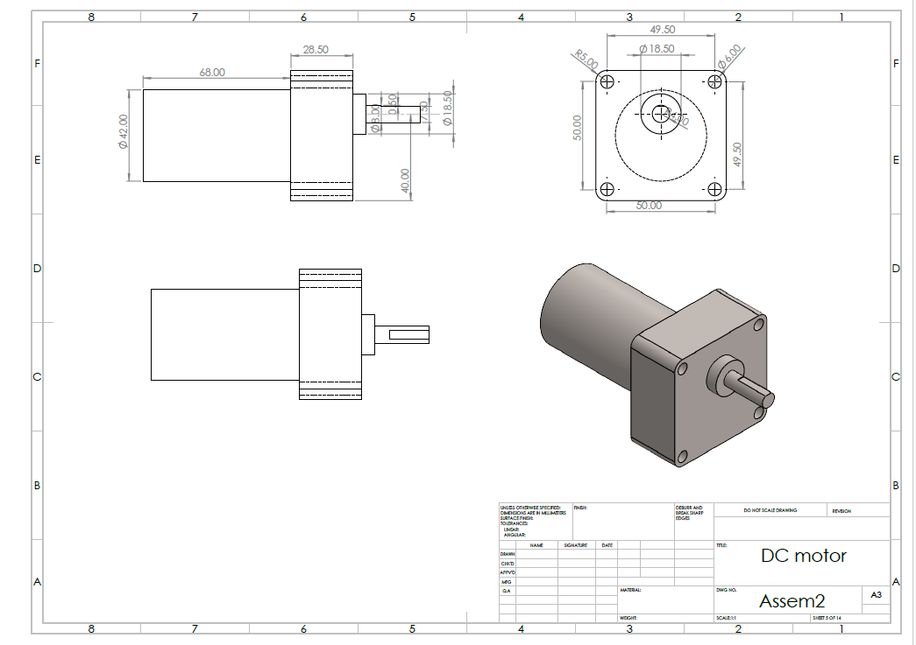

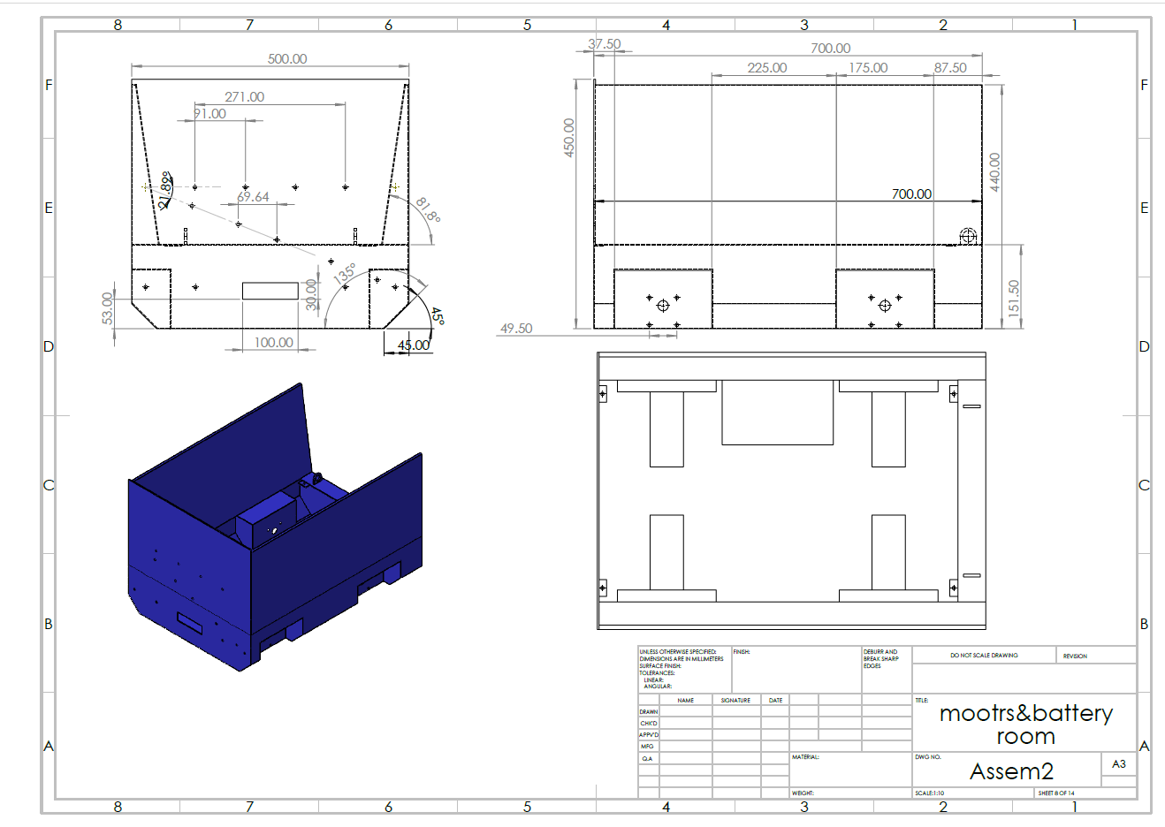

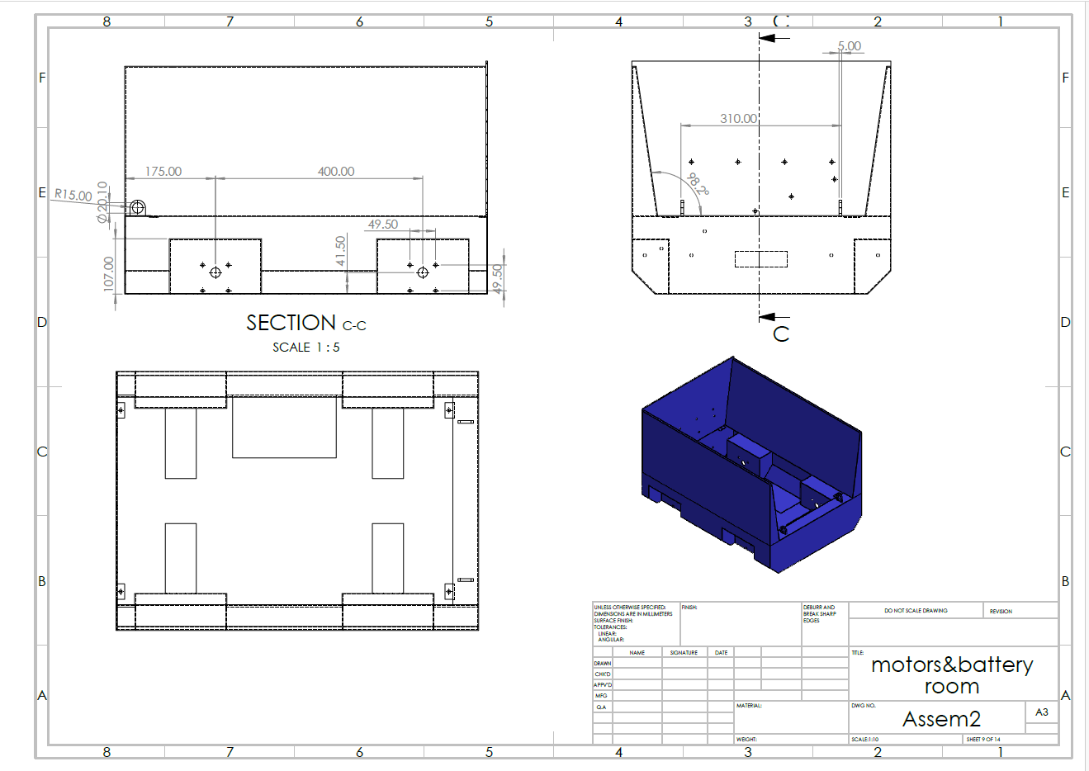

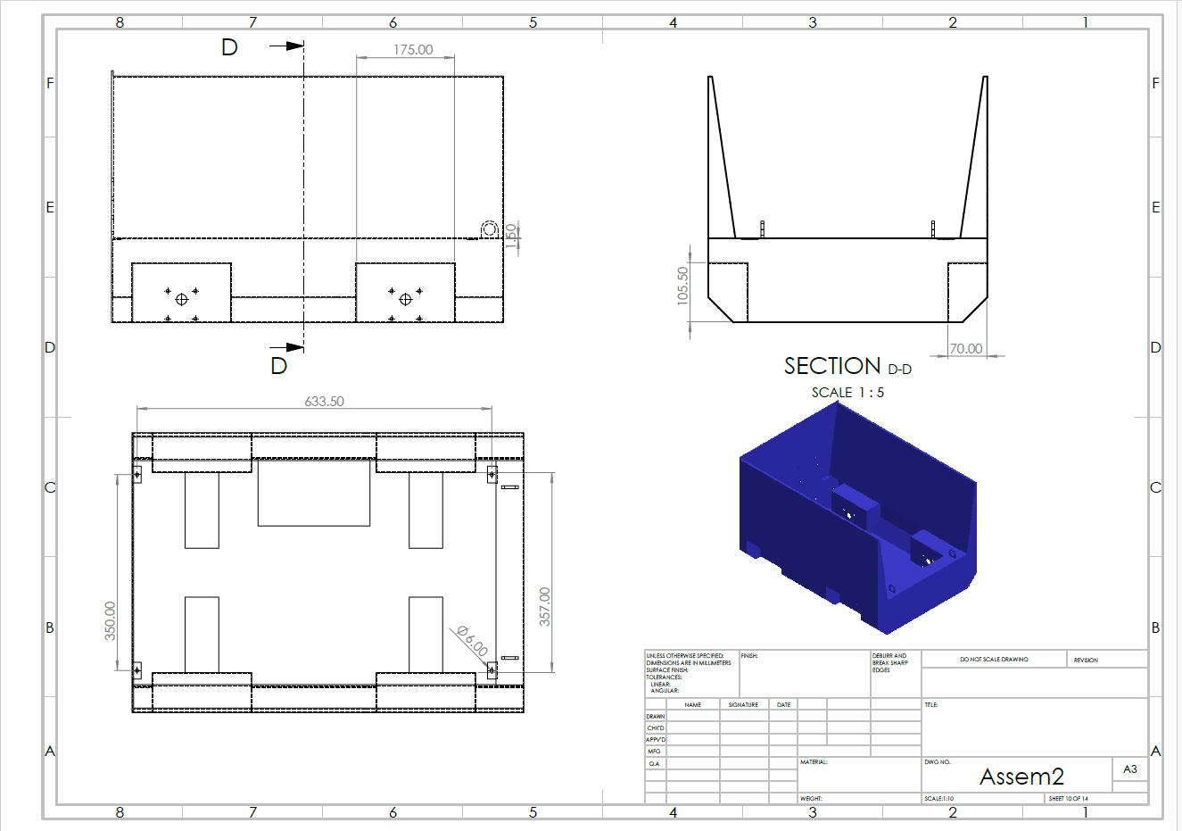

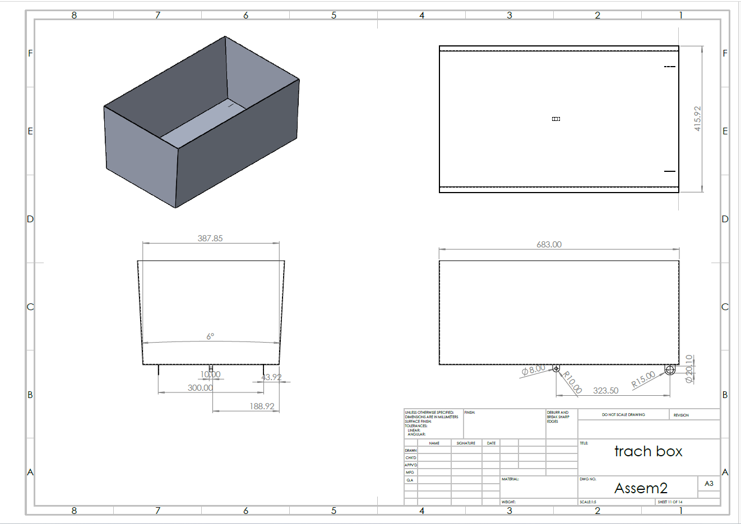

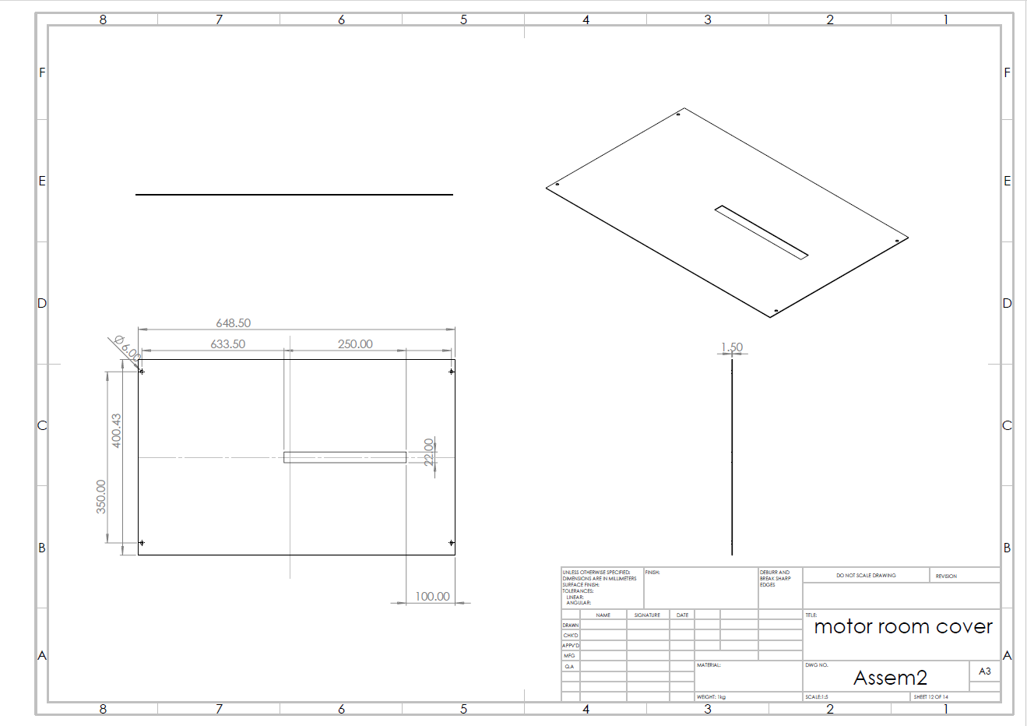

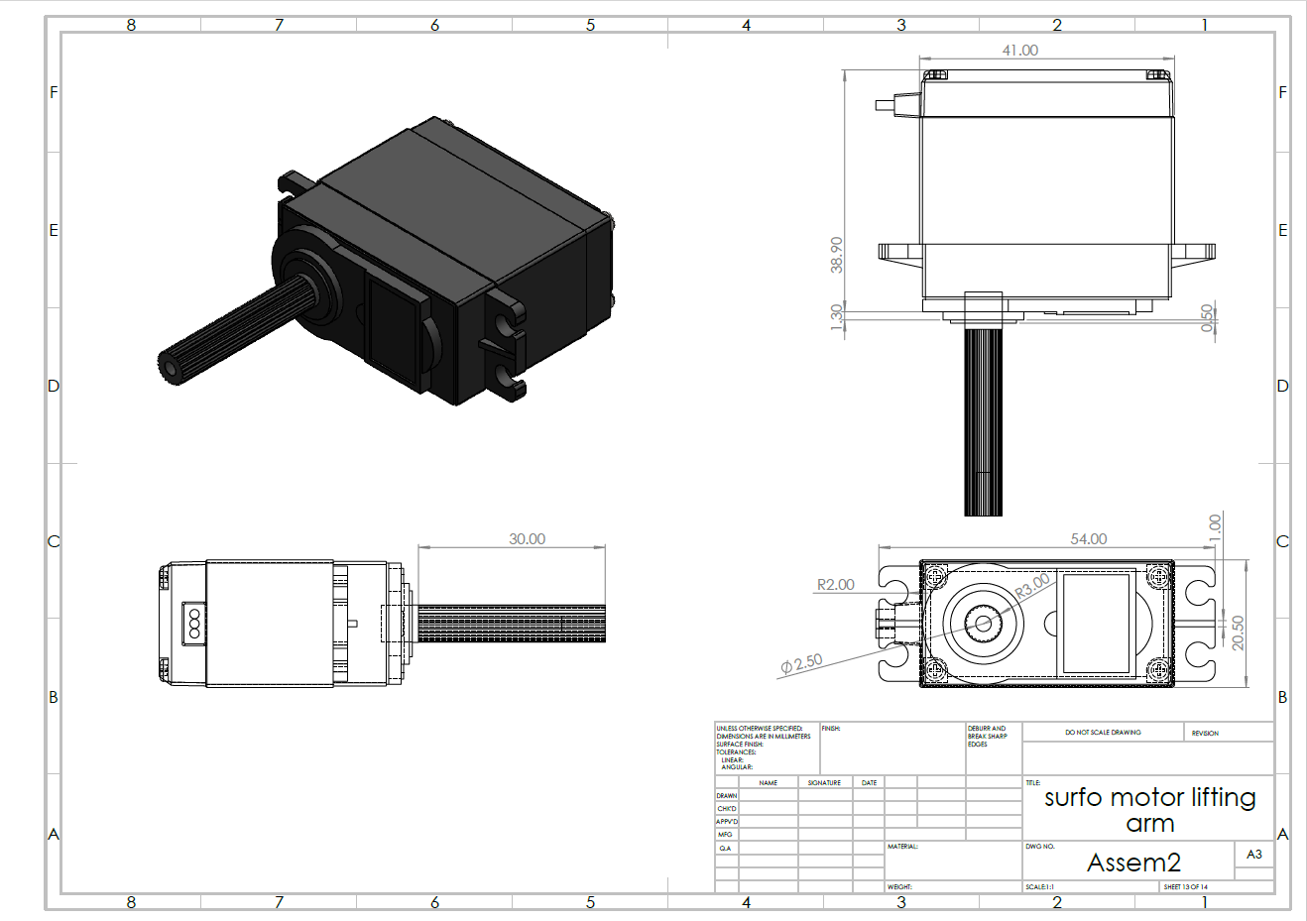

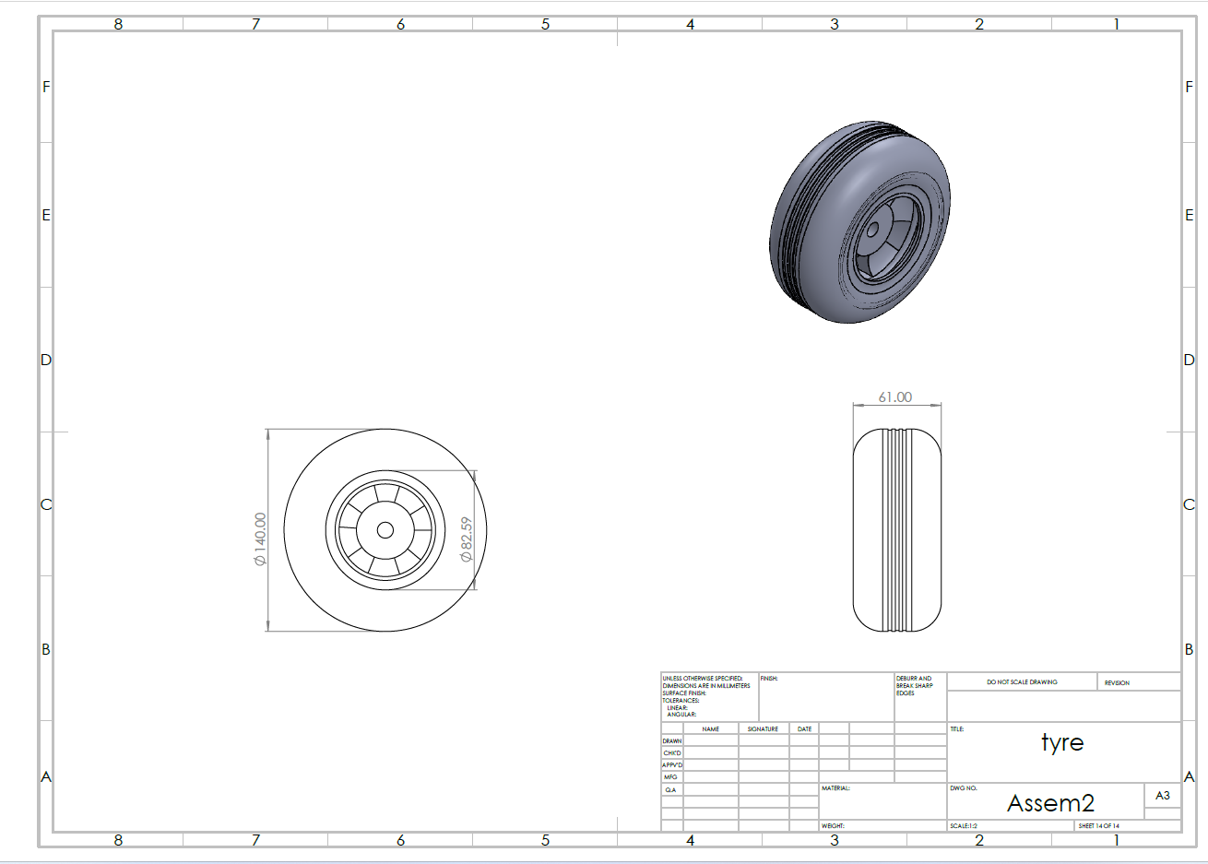

|  |  |  |  |  |  |  |  |  |  |  |  |  |  |  |  |  |  |
| --- | --- | --- | --- | --- | --- | --- | --- | --- | --- | --- | --- | --- | --- | --- | --- | --- | --- |
| |  |  |  |  |  | | --- | --- | --- | --- | --- | | |  | | --- | |   Figure 47Model name: motor unit | | | | | | **Solid Bodies** | | | | | **Document Name and Reference** | **Treated As** | **Volumetric Properties** |  | | **Cut-Extrude12**   | **Solid Body** | **Mass:7.91814 kg**  **Volume:0.00293264 m^3**  **Density:2,700 kg/m^3**  **Weight:77.5977 N** |  | |

## control unit analysis

|  |  |  |  |  |  |  |  |  |  |  |  |  |  |  |  |  |  |  |  |  |  |  |  |  |  |  |  |  |  |  |  |  |  |  |
| --- | --- | --- | --- | --- | --- | --- | --- | --- | --- | --- | --- | --- | --- | --- | --- | --- | --- | --- | --- | --- | --- | --- | --- | --- | --- | --- | --- | --- | --- | --- | --- | --- | --- | --- |
| **Study Properties**   |  |  | | --- | --- | | Study name | Static 1 | | Analysis type | Static | | Mesh type | Solid Mesh | | Thermal Effect: | On | | Thermal option | Include temperature loads | | Zero strain temperature | 298 Kelvin | | Include fluid pressure effects from SOLIDWORKS Flow Simulation | Off | | Solver type | Automatic | | Enplane Effect: | Off | | Soft Spring: | Off | | Inertial Relief: | Off | | Incompatible bonding options | Automatic | | Large displacement | Off | | Compute free body forces | On | | Friction | Off | | Use Adaptive Method: | Off | | Result folder | SOLIDWORKS document (D:\handasa\semster 9\mte599A\solid 2\parts) | |

|  |  |  |  |  |  |  |  |  |  |  |
| --- | --- | --- | --- | --- | --- | --- | --- | --- | --- | --- |
| **Units**   |  |  | | --- | --- | | Unit system: | SI (MKS) | | Length/Displacement | mm | | Temperature | Kelvin | | Angular velocity | Rad/sec | | Pressure/Stress | N/m^2 | |

|  |  |  |  |  |  |  |  |  |  |  |  |  |  |  |  |  |  |  |  |  |  |  |  |  |  |  |  |
| --- | --- | --- | --- | --- | --- | --- | --- | --- | --- | --- | --- | --- | --- | --- | --- | --- | --- | --- | --- | --- | --- | --- | --- | --- | --- | --- | --- |
| **Material Properties**   |  |  |  | | --- | --- | --- | | **Model Reference** | **Properties** | **Components** | | A blueprint of a building  Description automatically generated  Figure 48 motor unit | |  |  | | --- | --- | | **Name:** | **1060 Alloy** | | **Model type:** | **Linear Elastic Isotropic** | | **Yield strength:** | **2.75742e+07 N/m^2** | | **Tensile strength:** | **6.89356e+07 N/m^2** | | **Elastic modulus:** | **6.9e+10 N/m^2** | | **Poisson's ratio:** | **0.33** | | **Mass density:** | **2,700 kg/m^3** | | **Shear modulus:** | **2.7e+10 N/m^2** | | **Thermal expansion coefficient:** | **2.4e-05 /Kelvin** | | **Solid Body 1**  **(Cut-Extrude12)(motor unit )** | | **Curve Data: N/A** | | | |

|  |  |  |  |  |  |  |  |  |  |  |  |  |  |  |  |  |  |  |  |  |  |  |  |  |  |  |  |  |  |  |  |  |  |  |  |  |  |  |  |  |  |  |  |  |
| --- | --- | --- | --- | --- | --- | --- | --- | --- | --- | --- | --- | --- | --- | --- | --- | --- | --- | --- | --- | --- | --- | --- | --- | --- | --- | --- | --- | --- | --- | --- | --- | --- | --- | --- | --- | --- | --- | --- | --- | --- | --- | --- | --- | --- |
| **Loads and Fixtures**   | **Fixture name** | **Fixture Image** | **Fixture Details** | | --- | --- | --- | | **Fixed-1** | A 3d model of a building  Description automatically generated  Figure 49Fixture Image | |  |  | | --- | --- | | Entities: | **4 face(s)** | | Type: | **Fixed Geometry** | | | **Resultant Forces**   |  |  |  |  |  | | --- | --- | --- | --- | --- | | **Components** | **X** | **Y** | **Z** | **Resultant** | | **Reaction force(N)** | **1.60784e-05** | **73.575** | **-5.36442e-07** | **73.575** | | | |  | **Load name** | **Load Image** | **Load Details** | | --- | --- | --- | | **Force-1** | A computer generated image of a box  Description automatically generated  Figure 50 motor force | |  |  | | --- | --- | | Entities: | **4 face(s)** | | Type: | **Apply normal force** | | Value: | **9.81 N** | | | **Force-2** | Figure 51 battery force | |  |  | | --- | --- | | Entities: | **1 face(s)** | | Type: | **Apply normal force** | | Value: | **34.335 N** | | |

|  |  |  |  |  |  |  |  |  |  |  |  |  |  |  |  |  |  |  |  |  |  |  |  |  |  |  |  |  |
| --- | --- | --- | --- | --- | --- | --- | --- | --- | --- | --- | --- | --- | --- | --- | --- | --- | --- | --- | --- | --- | --- | --- | --- | --- | --- | --- | --- | --- |
| **Mesh information**   |  |  | | --- | --- | | Mesh type | Solid Mesh | | Mesher Used: | Blended curvature-based mesh | | Jacobian points for High quality mesh | 16 Points | | Maximum element size | 75.9919 mm | | Minimum element size | 3.7996 mm | | Mesh Quality | High |   **Mesh information – Details**   |  |  | | --- | --- | | Total Nodes | 31800 | | Total Elements | 15877 | | Maximum Aspect Ratio | 1,464.3 | | % of elements with Aspect Ratio < 3 | 11.1 | | Percentage of elements with Aspect Ratio > 10 | 40.4 | | Percentage of distorted elements | 0 | | Time to complete mesh(hh;mm;ss): | 00:00:07 | | Computer name: | IBRAHIM | |

|  |  |  |  |  |  |  |  |  |  |  |  |  |
| --- | --- | --- | --- | --- | --- | --- | --- | --- | --- | --- | --- | --- |
| **Reaction forces**   | Selection set | Units | Sum X | Sum Y | Sum Z | Resultant | | --- | --- | --- | --- | --- | --- | | Entire Model | N | 1.60784e-05 | 73.575 | -5.36442e-07 | 73.575 | |
| **Free body forces**   | Selection set | Units | Sum X | Sum Y | Sum Z | Resultant | | --- | --- | --- | --- | --- | --- | | Entire Model | N | 1.91184e-05 | 5.21019e-05 | -1.43629e-05 | 5.73273e-05 | |

|  |  |  |  |  |  |  |  |  |  |  |  |  |  |  |  |  |  |  |  |  |  |  |  |  |  |  |  |  |  |  |  |  |  |  |  |  |
| --- | --- | --- | --- | --- | --- | --- | --- | --- | --- | --- | --- | --- | --- | --- | --- | --- | --- | --- | --- | --- | --- | --- | --- | --- | --- | --- | --- | --- | --- | --- | --- | --- | --- | --- | --- | --- |
| **Study Results**   | Name | Type | Min | Max | | --- | --- | --- | --- | | Stress1 | VON: von Mises Stress | 1.607e-15N/m^2  Node: 12366 | 1.084e+06N/m^2  Node: 21478 | | Figure 52stedy for control unit  **motor unit -Static 1-Stress-Stress1** | | | |  | Name | Type | Min | Max | | --- | --- | --- | --- | | Displacement1 | URES: Resultant Displacement | 0.000e+00mm  Node: 43 | 8.686e-03mm  Node: 15683 | | Figure 53motor unit -Static 1-Displacement-Displacement1 | | | |  | Name | Type | Min | Max | | --- | --- | --- | --- | | Strain1 | ESTRN: Equivalent Strain | 0.000e+00  Element: 96 | 9.620e-06  Element: 6606 | | Figure 54motor unit -Static 1-Strain-Strain1 | | | | |

|  |  |  |  |  |  |  |  |  |  |  |  |  |  |  |  |  |  |
| --- | --- | --- | --- | --- | --- | --- | --- | --- | --- | --- | --- | --- | --- | --- | --- | --- | --- |
| crain arm analysis  |  |  |  |  |  | | --- | --- | --- | --- | --- | | |  | | --- | |   Figure 55Model name: Crain am |   **Current Configuration: Default** | | | | | **Solid Bodies** | | | | | **Document Name and Reference** | **Treated As** | **Volumetric Properties** | **Document Path/Date Modified** | | **Boss-Extrude2**   | **Solid Body** | **Mass:1.65403 kg**  **Volume:0.000612602 m^3**  **Density:2,700 kg/m^3**  **Weight:16.2095 N** |  | |

|  |  |  |  |  |  |  |  |  |  |  |  |  |  |  |  |  |  |  |  |  |  |  |  |  |  |  |  |  |  |  |  |  |  |  |
| --- | --- | --- | --- | --- | --- | --- | --- | --- | --- | --- | --- | --- | --- | --- | --- | --- | --- | --- | --- | --- | --- | --- | --- | --- | --- | --- | --- | --- | --- | --- | --- | --- | --- | --- |
| **Study Properties**   |  |  | | --- | --- | | Study name | Static 1 | | Analysis type | Static | | Mesh type | Solid Mesh | | Thermal Effect: | On | | Thermal option | Include temperature loads | | Zero strain temperature | 298 Kelvin | | Include fluid pressure effects from SOLIDWORKS Flow Simulation | Off | | Solver type | Automatic | | Inplane Effect: | Off | | Soft Spring: | Off | | Inertial Relief: | Off | | Incompatible bonding options | Automatic | | Large displacement | Off | | Compute free body forces | On | | Friction | Off | | Use Adaptive Method: | Off | | Result folder | SOLIDWORKS document | |

|  |  |
| --- | --- |
| Unit system: | SI (MKS) |
| Length/Displacement | mm |
| Temperature | Kelvin |
| Angular velocity | Rad/sec |
| Pressure/Stress | N/m^2 |

|  |
| --- |
|  |

|  |  |  |  |  |  |  |  |  |  |  |  |  |  |  |  |  |  |  |  |  |  |  |  |  |  |  |  |
| --- | --- | --- | --- | --- | --- | --- | --- | --- | --- | --- | --- | --- | --- | --- | --- | --- | --- | --- | --- | --- | --- | --- | --- | --- | --- | --- | --- |
| **Material Properties**   |  |  |  | | --- | --- | --- | | **Model Reference** | **Properties** | **Components** | | A blue and purple plastic object  Description automatically generated  Figure 56MATERIAL PROPERTIES | |  |  | | --- | --- | | **Name:** | **1060 Alloy** | | **Model type:** | **Linear Elastic Isotropic** | | **Yield strength:** | **2.75742e+07 N/m^2** | | **Tensile strength:** | **6.89356e+07 N/m^2** | | **Elastic modulus:** | **6.9e+10 N/m^2** | | **Poisson's ratio:** | **0.33** | | **Mass density:** | **2,700 kg/m^3** | | **Shear modulus:** | **2.7e+10 N/m^2** | | **Thermal expansion coefficient:** | **2.4e-05 /Kelvin** | | **SolidBody 1**  **(Boss-Extrude2)(crain am )** | | **Curve Data:N/A** | | | |

|  |  |  |  |  |  |  |  |  |  |  |  |  |  |  |  |  |  |  |  |  |  |  |  |  |  |  |  |  |  |  |  |  |  |  |  |  |  |  |  |  |
| --- | --- | --- | --- | --- | --- | --- | --- | --- | --- | --- | --- | --- | --- | --- | --- | --- | --- | --- | --- | --- | --- | --- | --- | --- | --- | --- | --- | --- | --- | --- | --- | --- | --- | --- | --- | --- | --- | --- | --- | --- |
| **Loads and Fixtures**   | **Fixture name** | **Fixture Image** | **Fixture Details** | | --- | --- | --- | | **Fixed-1** | A blue light on a grey surface  Description automatically generated  Figure 57 fixture image | |  |  | | --- | --- | | Entities: | **1 face(s)** | | Type: | **Fixed Geometry** | | | **Resultant Forces**   |  |  |  |  |  | | --- | --- | --- | --- | --- | | **Components** | **X** | **Y** | **Z** | **Resultant** | | **Reaction force(N)** | **2.70605e-05** | **24.525** | **7.7486e-07** | **24.525** | | **Reaction Moment(N.m)** | **0** | **0** | **0** | **0** | | | |  | **Load name** | **Load Image** | **Load Details** | | --- | --- | --- | | **Force-1** | Figure 58 load image | |  |  | | --- | --- | | Entities: | **1 face(s)** | | Type: | **Apply normal force** | | Value: | **24.525 N** | | |

|  |  |  |  |  |  |  |  |  |  |  |  |  |  |  |  |  |  |  |  |  |  |  |  |  |  |  |  |  |
| --- | --- | --- | --- | --- | --- | --- | --- | --- | --- | --- | --- | --- | --- | --- | --- | --- | --- | --- | --- | --- | --- | --- | --- | --- | --- | --- | --- | --- |
| **Mesh information**   |  |  | | --- | --- | | Mesh type | Solid Mesh | | Mesher Used: | Blended curvature-based mesh | | Jacobian points for High quality mesh | 16 Points | | Maximum element size | 16.9901 mm | | Minimum element size | 2.2961 mm | | Mesh Quality | High |   **Mesh information – Details**   |  |  | | --- | --- | | Total Nodes | 5693 | | Total Elements | 3363 | | Maximum Aspect Ratio | 4.4148 | | % of elements with Aspect Ratio < 3 | 98.6 | | Percentage of elements with Aspect Ratio > 10 | 0 | | Percentage of distorted elements | 0 | | Time to complete mesh(hh;mm;ss): | 00:00:03 | | Computer name: | IBRAHIM | |

|  |  |  |  |  |  |  |  |  |  |  |  |  |
| --- | --- | --- | --- | --- | --- | --- | --- | --- | --- | --- | --- | --- |
| **Resultant Forces**   | Selection set | Units | Sum X | Sum Y | Sum Z | Resultant | | --- | --- | --- | --- | --- | --- | | Entire Model | N | 2.70605e-05 | 24.525 | 7.7486e-07 | 24.525 | |
| **Free body forces**   | Selection set | Units | Sum X | Sum Y | Sum Z | Resultant | | --- | --- | --- | --- | --- | --- | | Entire Model | N | 2.71797e-05 | -6.28829e-06 | 1.04316e-06 | 2.79172e-05 | |

|  |  |  |  |  |  |  |  |  |  |  |  |  |  |  |  |  |  |  |  |  |  |  |  |  |  |  |  |  |  |  |  |  |  |  |  |  |
| --- | --- | --- | --- | --- | --- | --- | --- | --- | --- | --- | --- | --- | --- | --- | --- | --- | --- | --- | --- | --- | --- | --- | --- | --- | --- | --- | --- | --- | --- | --- | --- | --- | --- | --- | --- | --- |
| **Study Results**   | Name | Type | Min | Max | | --- | --- | --- | --- | | Stress1 | VON: von Mises Stress | 6.668e-01N/m^2  Node: 832 | 6.976e+06N/m^2  Node: 208 | | A blue object with screws  Description automatically generated  Figure 59Crain am -Static 1-Stress-Stress1 | | | |  | Name | Type | Min | Max | | --- | --- | --- | --- | | Displacement1 | URES: Resultant Displacement | 0.000e+00mm  Node: 16 | 8.298e-02mm  Node: 314 | | Figure 60 Crain forces | | | |  | Name | Type | Min | Max | | --- | --- | --- | --- | | Strain1 | ESTRN: Equivalent Strain | 8.786e-12  Element: 597 | 7.053e-05  Element: 2878 | | Figure 61crain am -Static 1-Strain-Strain1 | | | | |

|  |
| --- |
| * **Specifications**   A picture containing text, screenshot, number, font  Description automatically generated  Table 7 Specifications of ESP32 |

Appendix.B: **coding**

* **Main.cpp**

#include <ros.h>

#include <geometry_msgs/Twist.h>

#include <std_msgs/Float64.h>

#include <motor_control.h>

// #include <mpu6050.h>

#define COMMAND_RATE 5 // hz

double radius = 0.020;

double ly = 0.18;

double lx = 0.27;

double lower_speed_limit = -10;

double upper_speed_limit = 10;

double lower_pwm_limit = -255;

double upper_pwm_limit = 255;

static unsigned long prev_control_time = 0;

static unsigned long now = 0;

static unsigned long lastTime = 0;

ros::NodeHandle nh;

// ros::Publisher imu_pub("imu_raw", &floatArrayMsg);

void commandCallback(const geometry_msgs::Twist &cmd_msg)

{

  Vx = cmd_msg.linear.x;

  Vy = cmd_msg.linear.y;

  Wz = cmd_msg.angular.z;

}

void FourMecanumKinematic()

{

  // forward kinematics of a Four Mecanum Wheeled Mobile Robot

  w_fl = (1 / radius) * (Vx - Vy - (lx + ly) * Wz);

  w_fr = (1 / radius) * (Vx + Vy + (lx + ly) * Wz);

  w_rl = (1 / radius) * (Vx + Vy - (lx + ly) * Wz);

  w_rr = (1 / radius) * (Vx - Vy + (lx + ly) * Wz);

  // inverse kinematics of a Four Mecanum Wheeled Mobile Robot

  // Vx_ = (w_fl + w_fr + w_rl + w_rr) * (radius / 4);

  // Vy_ = (-w_fl + w_fr + w_rl - w_rr) * (radius / 4);

  // Wz_ = (-w_fl + w_fr - w_rl + w_rr) * (radius / (4 * (lx + ly)));

  pwm_fl = map(w_fl, lower_speed_limit, upper_speed_limit, lower_pwm_limit, upper_pwm_limit);

  pwm_fr = map(w_fr, lower_speed_limit, upper_speed_limit, lower_pwm_limit, upper_pwm_limit);

  pwm_rl = map(w_rl, lower_speed_limit, upper_speed_limit, lower_pwm_limit, upper_pwm_limit);

  pwm_rr = map(w_rr, lower_speed_limit, upper_speed_limit, lower_pwm_limit, upper_pwm_limit);

  // Serial.print("front right pwm: ");

  // Serial.println(pwm_fr);

  // Serial.print("front left pwm: ");

  // Serial.println(pwm_fl);

 motor_frontleft.setSpeed( pwm_fl);   // PWM 1A = Pin 10, PWM 1B = Pin 11.

 motor_frontright.setSpeed(pwm_fr);   // PWM 2A = Pin 8, PWM 2B = Pin 9.

 motor_backleft.setSpeed(pwm_rl);   // PWM 1A = Pin 10, PWM 1B = Pin 11.

 motor_backright.setSpeed(pwm_rr);   // PWM 2A = Pin 8, PWM 2B = Pin 9.

  // if (Vx > 0)

  // {

  //   straightAhead(pwm_fl, pwm_fr, pwm_rl, pwm_rr);

  // }

  // else if (Wz > 0)

  // {

  //   turnRound(pwm_fl, pwm_fr, pwm_rl, pwm_rr);

  // }

  // else if (Wz < 0)

  // {

  //   turnRoundInv(pwm_fl, pwm_fr, pwm_rl, pwm_rr);

  // }

  // else if (Vx < 0)

  // {

  //   straightBack(pwm_fl, pwm_fr, pwm_rl, pwm_rr);

  // }

  // else

  // {

  //   OFF();

  // }

}

ros::Subscriber<geometry_msgs::Twist> sub("/cmd_vel", &commandCallback);

void setup()

{

  // Inizialize the ROS node on the Arduino

  nh.initNode();

  motorsSetup();

  // Serial.begin(9600);

  // Inform ROS that this node will subscribe to messages on a given topic

  nh.subscribe(sub);

  // nh.advertise(imu_pub);

  // setupIMU();

}

void loop()

{

  // now = millis();

  // int timeChange = (now - lastTime);

  // if ((millis() - prev_control_time) >= (1000 / COMMAND_RATE))

  // {

    FourMecanumKinematic();

    // publishIMU();

    // lastTime = now;

  // }

  // imu_pub.publish(&floatArrayMsg);

  nh.spinOnce();

  delay(1);

  // delay(2000);  // Wait for 2 seconds

}

* **IMU_publisher.cpp**

#include <ros/ros.h>

#include <std_msgs/Float32MultiArray.h>

#include "sensor_msgs/Imu.h"

#include <tf2/LinearMath/Quaternion.h>

#include <tf2/LinearMath/Matrix3x3.h>

ros::Publisher imu_pub;

ros::Subscriber imu_raw_sub;

sensor_msgs::Imu imu_data;

ros::Time current_time, last_time;

// Create a Quaternion

tf2::Quaternion quaternion;

double roll = 0.0;  // roll angle

double pitch = 0.0; // pitch angle

double yaw = 0.0;   //  yaw angle

double linear_acc_x = 0.0;  // roll angle

double linear_acc_y = 0.0; // pitch angle

double linear_acc_z = 0.0;   //  yaw angle

void IMUCallback(const std_msgs::Float32MultiArray::ConstPtr &raw_imu_msg)

{

  yaw = raw_imu_msg->data[0];

  pitch = raw_imu_msg->data[1];

  roll = raw_imu_msg->data[2];

  linear_acc_x= 0;

  linear_acc_y=0;

  linear_acc_z=1;

}

int main(int argc, char **argv)

{

  ros::init(argc, argv, "imu_publisher");

  ros::NodeHandle nh;

  imu_raw_sub = nh.subscribe("imu_raw", 50, IMUCallback);

  imu_pub = nh.advertise<sensor_msgs::Imu>("imu", 50);

  current_time = ros::Time::now();

  last_time = ros::Time::now();

  ros::Rate loop_rate(50);

  while (ros::ok())

  {

    ros::spinOnce();

    // Set the quaternion using Euler angles

    quaternion.setRPY(roll, pitch, yaw);

    imu_data.orientation.x = quaternion.x();

    imu_data.orientation.y = quaternion.y();

    imu_data.orientation.z = quaternion.z();

    imu_data.orientation.w = quaternion.w();

    imu_data.linear_acceleration.x=linear_acc_x;

    imu_data.linear_acceleration.y=linear_acc_y;

    imu_data.linear_acceleration.z=linear_acc_z;

    imu_data.header.frame_id = "imu_link";

    current_time = ros::Time::now();

    imu_data.header.stamp = current_time;

    imu_pub.publish(imu_data);

    last_time = current_time;

    loop_rate.sleep();

  }

  return 0;

}

* **motor_control.h**

#include <Arduino.h>

#include "CytronMotorDriver.h"

// Pin definitions for motor control

const int motorFL1 = 2;       // Front-left motor positive

const int motorFL2 = 15;        // Front-left motor negative

const int motorBL1 = 27;       // Back-left motor positive

const int motorBL2 = 14;       // Back-left motor negative

const int motorBR1 = 8;       // Back-right motor positive

const int motorBR2 = 11;       // Back-right motor negative

const int motorFR1 = 4;       // Front-right motor positive

const int motorFR2 = 5;       // Front-right motor negative

CytronMD motor_frontleft(PWM_DIR, motorFL1,motorFL2);   //  PWM 1 = motorFL1, DIR 1 = motorFL2.

CytronMD motor_frontright(PWM_DIR,motorFR1,motorFR2);   //  PWM 1 = motorFR1, DIR 1 = motorFR2 .

CytronMD motor_backleft(PWM_DIR,motorBL1,motorBL2);   // PWM 1 = motorBL1, DIR 1 = motorBL2.

CytronMD motor_backright(PWM_DIR,motorBR1,motorBR2);   // PWM 1 = motorBR1, DIR 1 = motorBR2.

double w_fl;

double w_fr;

double w_rl;

double w_rr;

double Vx = 0.0;

double Vy = 0.0;

double Wz = 0.0;

// double Vx_ = 0;

// double Vy_ = 0;

// double Wz_ = 0;

double pwm_fl = 0;

double pwm_fr = 0;

double pwm_rl = 0;

double pwm_rr = 0;

void motorsSetup(){

  // Set motor control pins as outputs

  pinMode(motorFL1, OUTPUT);

  pinMode(motorFL2, OUTPUT);

  pinMode(motorFR1, OUTPUT);

  pinMode(motorFR2, OUTPUT);

  pinMode(motorBL1, OUTPUT);

  pinMode(motorBL2, OUTPUT);

  pinMode(motorBR1, OUTPUT);

  pinMode(motorBR2, OUTPUT);

}

// Function to move the robot forward

void straightAhead(double v_fl, double v_fr, double v_rl, double v_rr)

{

    // Set enable pins HIGH to enable the motors

    digitalWrite(motorFL1, HIGH);

    digitalWrite(motorFL2, LOW);

    digitalWrite(motorFR1, HIGH);

    digitalWrite(motorFR2, LOW);

    digitalWrite(motorBL1, HIGH);

    digitalWrite(motorBL2, LOW);

    digitalWrite(motorBR1, HIGH);

    digitalWrite(motorBR2, LOW);

}

void straightBack(double v_fl, double v_fr, double v_rl, double v_rr)

{

    // Set enable pins HIGH to enable the motors

    digitalWrite(motorFL1, LOW);

    digitalWrite(motorFL2, HIGH);

    digitalWrite(motorFR1, LOW);

    digitalWrite(motorFR2, HIGH);

    digitalWrite(motorBL1, LOW);

    digitalWrite(motorBL2, HIGH);

    digitalWrite(motorBR1, LOW);

    digitalWrite(motorBR2, HIGH);

}

void sideWay(double v_fl, double v_fr, double v_rl, double v_rr)

{

    // Set enable pins HIGH to enable the motors

    digitalWrite(motorFL1, HIGH);

    digitalWrite(motorFL2, LOW);

    digitalWrite(motorFR1, LOW);

    digitalWrite(motorFR2, HIGH);

    digitalWrite(motorBL1, LOW);

    digitalWrite(motorBL2, HIGH);

    digitalWrite(motorBR1, HIGH);

    digitalWrite(motorBR2, LOW);

}

void sideWayInv(double v_fl, double v_fr, double v_rl, double v_rr)

{

    // Set enable pins HIGH to enable the motors

    digitalWrite(motorFL1, LOW);

    digitalWrite(motorFL2, HIGH);

    digitalWrite(motorFR1, HIGH);

    digitalWrite(motorFR2, LOW);

    digitalWrite(motorBL1, HIGH);

    digitalWrite(motorBL2, LOW);

    digitalWrite(motorBR1, LOW);

    digitalWrite(motorBR2, HIGH);

}

void turnRound(double v_fl, double v_fr, double v_rl, double v_rr)

{

    // Set enable pins HIGH to enable the motors

    digitalWrite(motorFL1, HIGH);

    digitalWrite(motorFL2, LOW);

    digitalWrite(motorFR1, LOW);

    digitalWrite(motorFR2, HIGH);

    digitalWrite(motorBL1, HIGH);

    digitalWrite(motorBL2, LOW);

    digitalWrite(motorBR1, LOW);

    digitalWrite(motorBR2, HIGH);

}

void turnRoundInv(double v_fl, double v_fr, double v_rl, double v_rr)

{

    // Set enable pins HIGH to enable the motors

    digitalWrite(motorFL1, LOW);

    digitalWrite(motorFL2, HIGH);

    digitalWrite(motorFR1, HIGH);

    digitalWrite(motorFR2, LOW);

    digitalWrite(motorBL1, LOW);

    digitalWrite(motorBL2, HIGH);

    digitalWrite(motorBR1, HIGH);

    digitalWrite(motorBR2, LOW);

}

void OFF()

{

    // Set enable pins HIGH to enable the motors

}

* **mpu6050.h**

#include "I2Cdev.h"

#include "MPU6050_6Axis_MotionApps20.h"

//#include "MPU6050.h" // not necessary if using MotionApps include file

// Arduino Wire library is required if I2Cdev I2CDEV_ARDUINO_WIRE implementation

// is used in I2Cdev.h

#if I2CDEV_IMPLEMENTATION == I2CDEV_ARDUINO_WIRE

#include "Wire.h"

#endif

#include <std_msgs/Float32MultiArray.h>

MPU6050 mpu;

//MPU6050 mpu(0x69); // <-- use for AD0 high

bool blinkState = false;

// MPU control/status vars

bool dmpReady = false;  // set true if DMP init was successful

uint8_t mpuIntStatus;   // holds actual interrupt status byte from MPU

uint8_t devStatus;      // return status after each device operation (0 = success, !0 = error)

uint16_t packetSize;    // expected DMP packet size (default is 42 bytes)

uint16_t fifoCount;     // count of all bytes currently in FIFO

uint8_t fifoBuffer[64]; // FIFO storage buffer

// orientation/motion vars

Quaternion q;           // [w, x, y, z]         quaternion container

VectorInt16 aa;         // [x, y, z]            accel sensor measurements

VectorInt16 aaReal;     // [x, y, z]            gravity-free accel sensor measurements

VectorInt16 aaWorld;    // [x, y, z]            world-frame accel sensor measurements

VectorFloat gravity;    // [x, y, z]            gravity vector

float euler[3];         // [psi, theta, phi]    Euler angle container

float ypr[3];           // [yaw, pitch, roll]   yaw/pitch/roll container and gravity vector

float imu_data[6];

// packet structure for InvenSense teapot demo

uint8_t teapotPacket[14] = { '$', 0x02, 0, 0, 0, 0, 0, 0, 0, 0, 0x00, 0x00, '\r', '\n' };

volatile bool mpuInterrupt = false;     // indicates whether MPU interrupt pin has gone high

void dmpDataReady() {

  mpuInterrupt = true;

}

std_msgs::Float32MultiArray floatArrayMsg;

//std_msgs::Float32 floatMsg;

//ros::Publisher imu_pub("imu", &floatMsg);

void setupIMU(){

  //  nh.getHardware()->setBaud(57600);

#if I2CDEV_IMPLEMENTATION == I2CDEV_ARDUINO_WIRE

  Wire.begin();

  Wire.setClock(400000); // 400kHz I2C clock. Comment this line if having compilation difficulties

#elif I2CDEV_IMPLEMENTATION == I2CDEV_BUILTIN_FASTWIRE

  Fastwire::setup(400, true);

#endif

  mpu.initialize();

  devStatus = mpu.dmpInitialize();

  // supply your own gyro offsets here, scaled for min sensitivity

  mpu.setXGyroOffset(-15);

  mpu.setYGyroOffset(20);

  mpu.setZGyroOffset(0);

  mpu.setZAccelOffset(1788); // 1688 factory default for my test chip

  mpu.CalibrateAccel(6);

  mpu.CalibrateGyro(6);

  mpu.PrintActiveOffsets();

  mpu.setDMPEnabled(true);

  mpuIntStatus = mpu.getIntStatus();

  dmpReady = true;

  packetSize = mpu.dmpGetFIFOPacketSize();

  // Resize the array to the desired size

  floatArrayMsg.data_length = 6; // Adjust the size according to your needs

}

void publishIMU()

{

 //

  if (!dmpReady) return;

  // read a packet from FIFO

  if (mpu.dmpGetCurrentFIFOPacket(fifoBuffer)) { // Get the Latest packet

    // display Euler angles in degrees

    mpu.dmpGetQuaternion(&q, fifoBuffer);

    mpu.dmpGetEuler(euler, &q);

    imu_data[0] = euler[0] ;

    imu_data[1] = euler[1] ;

    imu_data[2] = euler[2];

    mpu.dmpGetQuaternion(&q, fifoBuffer);

    mpu.dmpGetAccel(&aa, fifoBuffer);

    mpu.dmpGetGravity(&gravity, &q);

    mpu.dmpGetLinearAccel(&aaReal, &aa, &gravity);

    imu_data[3] = aaReal.x /10 ;

    imu_data[4] = aaReal.y /10 ;

    imu_data[5] = aaReal.z/10;

    floatArrayMsg.data=imu_data;

    // blink LED to indicate activity

    blinkState = !blinkState;

    // nh.spinOnce();

  }

}

#### Appendix.c: Table of cost

|  |  |  |
| --- | --- | --- |
| Components | N.O pieces | Cost (L.E) |
| Raspberry Pi | 1 | 6000 |
| RP-LIDAR | 1 | 7000 |
| DC Motor Driver | 2 | 4500 |
| ESP32 | 1 | 450 |
| USB HUB (BYEASY) | 1 | 250 |
| Wire connector 2 in 8 | 1 | 175 |
| Loadcell | 1 | 150 |
| Camera kinect | 1 | 1400 |
| FeeTech 65kg Encoders Steel Gear Servo | 1 | 2000 |
| BETU 45Kg Coreless Servo Motor | 2 | 5400 |
| SG775125000-90K  DC Motor | 4 | 4800 |
|  |  |  |
|  |  |  |
| TOTAL COST |  | 32125 |